School of Mathematics and Statistics Newsletter

June 2025

# Congratulations to ...

• Dimitrios Katsaounis who on 3rd May successfully defended his PhD thesis entitled ‘Multiscale Modelling of Cancer Invasion and Metastasis: Integrating Stochastic and Continuum Approaches’.

# Welcome to ...

• Stuart Mackintosh who joins our Research Administration Team on 16th June. Stuart joins us from Registry and has a wealth of Administration experience including Research Administration from his time working at the University of Cambridge.

• Casey Brown who joins the Teaching Administration Team on 12th June, coming from the University of Dundee. Casey will be working part time (on Thursdays and Fridays) on a job-share with Lauren Sheppard (who now works on Mondays, Tuesdays and Wednesdays).

# Farewell to ...

• Fiona MacFarlane who is retiring at the end of June. Fiona has worked for the University since 2001 and joined our School in 2004 as secretary for the Solar and Magnetospheric Theory Group, then funded by a PPARC Rolling Grant. Over more than 20 years with the SMTG and the School she has among other tasks administered many research grants, helped with the preparations for grant applications, guided PhD students, postdocs and staff through the ever-changing regulations for claiming expenses and other University Admin matters, and she has been indispensable for organising many conferences, workshops and summer schools. Most astonishingly Fiona seems to have enjoyed these tasks! Her ability of having a laugh instead of despairing about the absurdities of dealing with the combination of University (and other) regulations and academics will certainly have helped. We wish Fiona a happy retirement!

• Chrissy Fell who is leaving St Andrews and academia to move to a role in data analysis in the commercial sector. She has been in St Andrews for a long time, first as an MSc and PhD student in Statistics, then a Data Scientist with Medicine and Computer Science, and since August 2023 as an Associate Lecturer (Education Focused) in Statistics in our School.

• Lesley McWhirter who has been a cleaner in the Maths Institute building for many years and who retired at the end of May.

# Visitors

• James East from the Western Sydney University is visiting Nik Ruskuc from 6-28th June. They will continue work on free projection- and idempotent-generated semigroups. James also has ongoing projects with James Mitchell and other members of the Algebra and Combinatorics Research Group.

• Andy Lynch hosted a visit by Radek Lach from Cambridge in June to develop their work on the analysis of prostate cancer epigenetics.

• Mark Holland from Exeter visited Mike Todd for a week in mid-May to work on recurrence in dynamical systems. Stefano Luzzatto from the International Centre for Theoretical Physics (ICTP), Trieste (in Scotland for an LMS meeting at ICMS on UK/Africa Partnerships) also visited for a day during that week to discuss research projects.

• On 3rd June the School hosted Maurice Chiodo, from the University of Cambridge, for the biannual seminar in educational research organised by Stefania Lisai. Maurice talked about the importance of discussing ethics in mathematics with our students. The hybrid seminar caught the interest of colleagues from other Schools, and was followed by an interesting conversation in the Staff Room.

# Conferences, Talks and Visits

• At the hybrid *Workshop on Combinatorial and Additive Number Theory* at CUNY Graduate Center, New York, held on 20th-23rd May, Jon Fraser gave a talk on ‘Averages of the Fourier transform in finite fields’, Firdavs Rakhmonov spoke on ‘Exceptional projections on finite fields’ and Sophie Huczynska on ‘Additive triples in groups of odd prime order’.

• Jon Fraser gave a *Dynamics Seminar* at the University of Bristol on 16th May entitled ‘Orbital sets in conformal dynamics’ on joint work with Yunlong Xu.

• Mike Todd visited Bristol for eight days to work with their dynamics group and spoke in a *One Day Ergodic Theory and Dynamical Systems* meeting on ‘Almost sure orbits closeness’.

• Saeed Shaabanian presented a poster at the summer school and workshop *Beyond Uniform Hyperbolicity 2025* that took place at the ICTP in Trieste from 2nd-13th June.

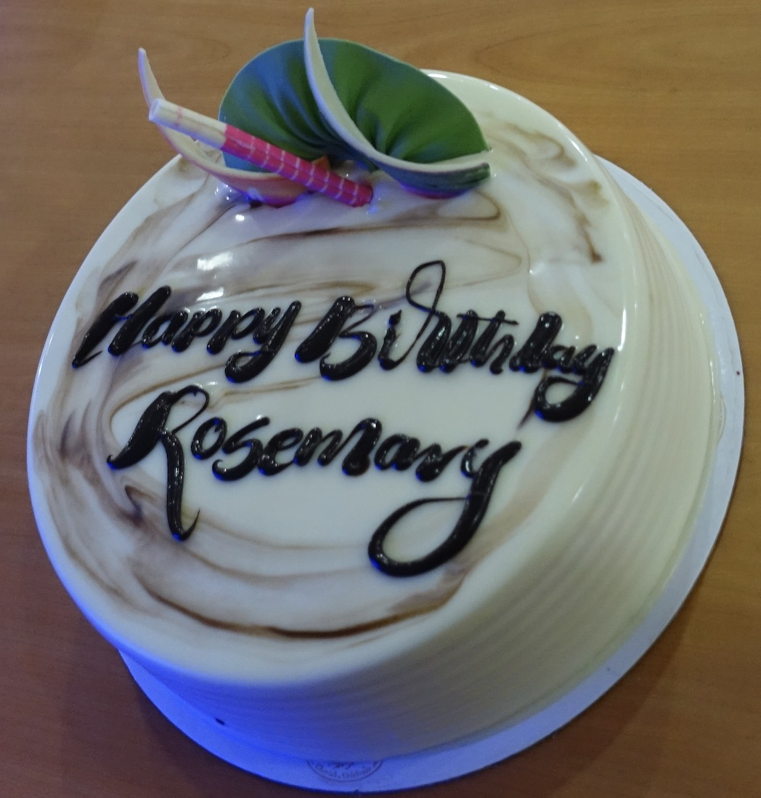• Rosemary Bailey and Peter Cameron were in Kochi, Kerala, India, from 5-11th June. Peter was a plenary speaker at the *International Conference on Discrete Mathematics* 2025, organised by the Academy of Discrete Mathematics and its Applications at Cochin University of Science and Technology (CUSAT). He gave a talk on ‘Six views of discrete mathematics through the window of the Shrikhande graph’, and also gave a short keynote address at the opening ceremony. He also chaired the first *S.S. Shrikhande Memorial Endowment* lecture, given by Rajendra Pawale. His last visit to CUSAT was fifteen years ago. Rosemary spoke to 100 senior students at the Bharathiya Vidya Bhavan school on ‘A life in Mathematics’. The Conference marked her birthday on the opening day with a delicious birthday cake.

• Colva Roney-Dougal and Peiran Wu went to the *Computational Group Theory* *Workshop* at the Oberwolfach Research Institute for Mathematics from 1st-6th June. Colva was an organiser of the workshop and Peiran gave a short talk and a software demo.

• Jung Won Cho (Cho) attended the workshop on *Diophantine Problems in One-Relator Inverse Monoids* at the University of East Anglia from 19th-23rd May. During the workshop, Cho gave a talk on free inverse monoids.

• Sophie Huczynska is visiting the University of Bristol from 3rd-12th June. She attended an FRG (Focused Research Grant) workshop, spent time collaborating with her former PhD student Laura Johnson (now a postdoc at Bristol) and on 11th June will be an invited speaker at the Bristol One Day Meeting in Combinatorics.

• Josh Shelton visited the New Jersey Institute of Technology (NJIT) for 4-5th June, and gave a talk on ‘Subharmonic instability of large-amplitude gravity-capillary waves’ at the conference *Frontiers in Applied and Computational Mathematics 2025*.

*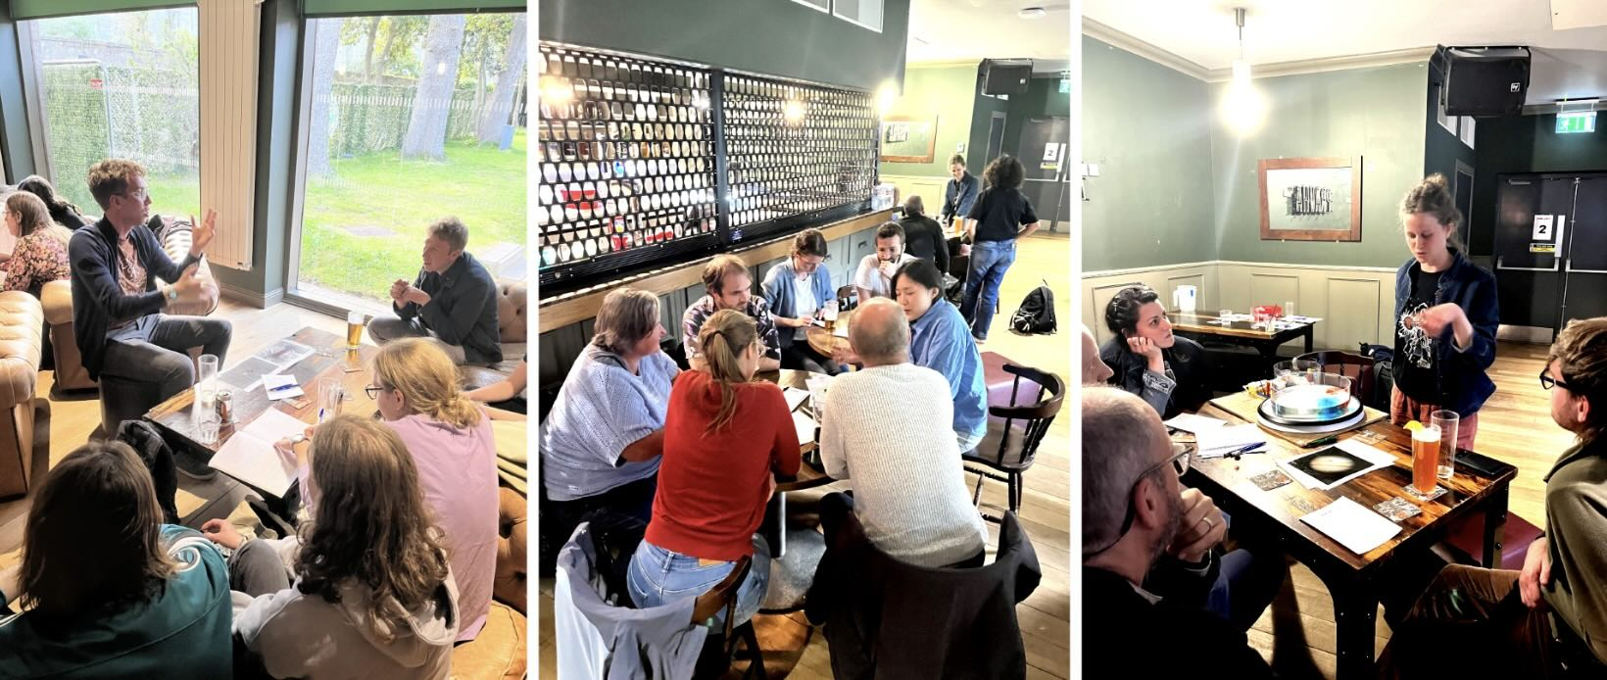Scenes from the Pint of Science Festival*

• From 19th-21st May, St Andrews played host to the *Pint of Science* festival at Sandy’s bar, with several members of the School involved, including Gabby Arrieta, Grace Edmondson, Daphné Lemasquerier and Sarah Rehman who were part of the organising team. Jonah Klowss and Daphné spoke at the speed researching session of the Atoms to Galaxies event, demonstrating concepts around the magnetic field of stars and the effect of rotation on fluid flows. Amber Cowans gave a talk on the ecological applications of AI at the Tech Me Out event, with a special focus how AI helps us to identify bird species in conservation.

• Ben Swallow attended the *Bayesian Inference in Statistic Processes 14* conference in Milan from 26-28th May where he contributed a talk on ‘Bayesian inference for oscillatory systems using the pcLNA algorithm’. This was followed by *Bioinference25* from 28-30th May in Bardonnecchia, a town in the Alps near Turin, where Ben gave an invited talk on ‘Scalable Gaussian Processes as a tool in mathematical epidemiology’.

• Andy Lynch attended (virtually) a prostate cancer meeting in Bologna form 12-14th May.

• Bromlyn Cameron attended the online workshop *An Introduction to Knowledge Exchange in the Mathematical Sciences* on 20th and 22nd May. This short training course, run by the KE Hub for Mathematical Sciences, helped graduate students develop skills used in knowledge exchange to solve real-world problems using mathematics. The course was engaging and highly interactive, and relevant to students from Pure, Applied and Statistics.

• Charles Paxton gave a public talk on ‘Statistics and Sea Monsters’ at the Aberdeen Art Gallery, on 4th June as part of their *Monsters of the Deep* exhibition and events.

# Other News

• Nikos Sfakianakis has been elected a board member of the *European Society for Mathematical Biology* (ESMB). The mission of the ESMTB is to ‘promote theoretical approaches and mathematical tools in biology and medicine in a European and wider context’. Together with the Society for Mathematical Biology (SMB) based in the United States, ESMTB is one of the two principal international bodies dedicated to supporting and advancing Mathematical Biology worldwide.

• Michael Papathomas has been awarded a grant of £3,330 as Principal Investigator for a Research in Groups project from the International Centre for Mathematical Sciences (ICMS) in Edinburgh, for a research visit by Georgy Sofronov (Macquarie University). Along with other collaborators (PI Frank Sullivan) Michael also obtained a grant of total value £131,193 from The Sepsis Trust for the project ‘Identification of earlier opportunities to diagnose sepsis using EMRs’.

• Sarah Rehman spent between December 2024 and March 2025 collaborating with a composer from the Royal Conservatoire of Scotland to create a piece of music inspired by her PhD research on disease and dispersal dynamics in a metapopulation of water voles. The composition, titled ‘Parasitism’, opened the show at the Laidlaw Music Centre on 8th May as part of the ‘Intersections’ performance. The piece features a flute, clarinet, bass clarinet, violin, cello and piano. You can listen to the full evening of performances at www.youtube.com/watch?v=cmT41YymE_c..

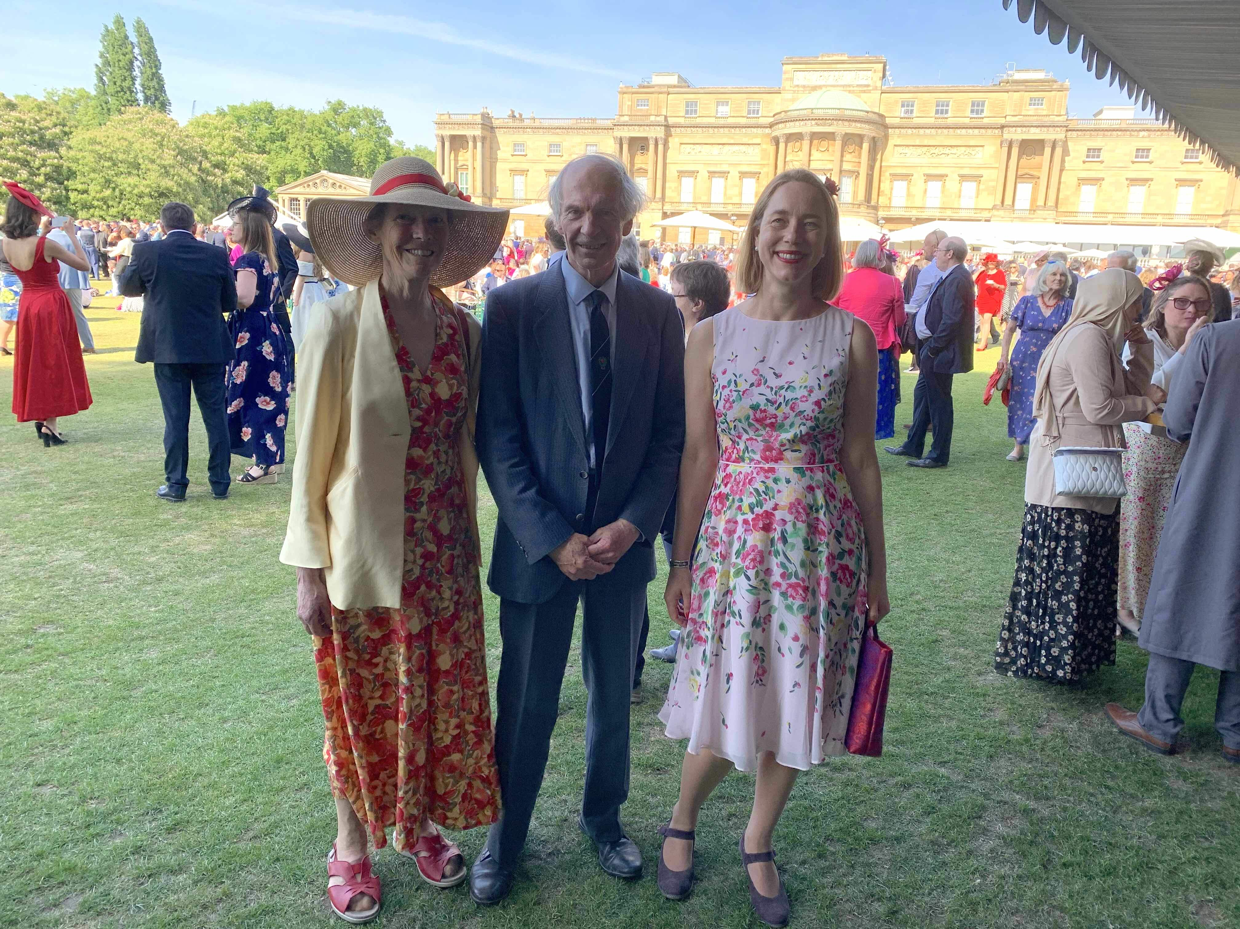• On 14th May, Colva Roney-Dougal, Isobel Falconer and Kenneth Falconer attended a garden party at Buckingham Palace hosted by His Majesty the King to celebrate education and skills.

# Future Events

• To celebrate Fiona MacFarlane’s ongoing contribution to the School and University (see above), there will be a coffee and cake celebration on Monday 27th June from 3.00-4.30pm in room 1A of the Mathematical Institute. All are welcome!

• The *38th North British Semigroups and Applications Network* (NBSAN) meeting will be held on 12-13th June in St Andrews, organised by Jung Won Cho, Murray Whyte and Nik Ruskuc. Details can be found at https://sites.google.com/view/stanbsan25/home There will also be a smaller Semigroups Day on 19th June.

# Caption Competition

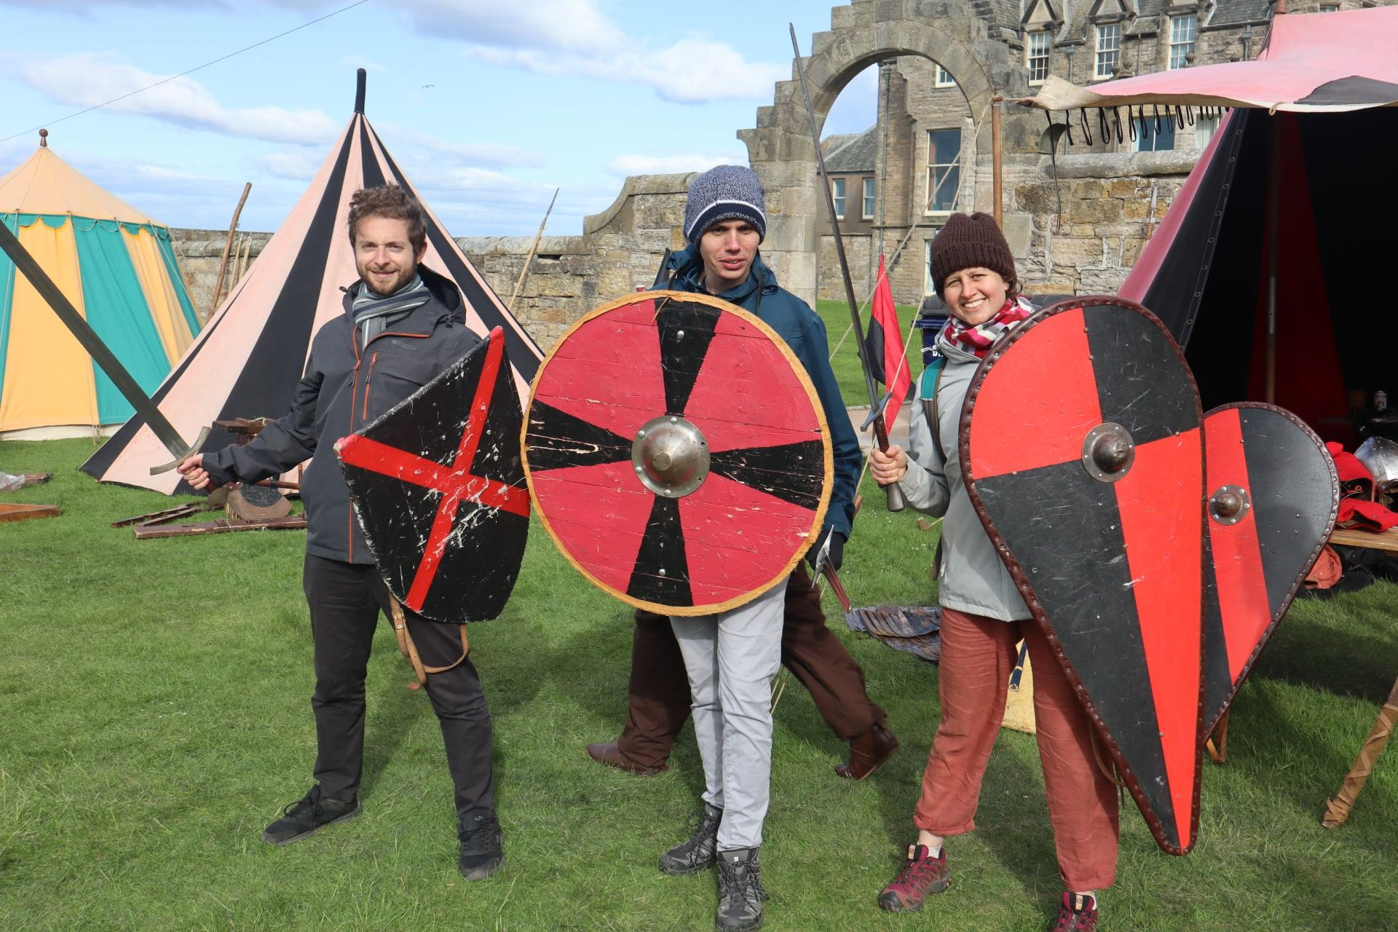• The May Newsletter invited captions for the picture of seminar speaker Eric Hester with Josh Shelton and Daphné Lemasquerier. Captions received included:

“Applied maths seminar speakers need to be provided with protection in case of a hostile audience”

“Following university cuts alternative security arrangements have been put in place”

# Next Issue

• The next edition of the School Newsletter will be circulated in July. Items may be sent to maths-news@st-andrews.ac.uk at any time but a reminder will be sent out a week before the deadline.