School of Mathematics and Statistics Newsletter

April 2025

Congratulations to ...
• our Director of Teaching, David Rees Jones, who has been awarded one of the University’s four Teaching Excellence Awards for the academic session 2024-25. David’s award recognises the excellence both in his own teaching and his teaching leadership in the School.
• Lilli Nadol on successfully defending her thesis entitled ‘Three-dimensional solar magnetic field extrapolation using analytical magnetohydrostatic equilibrium solutions’ on 12th March.
• Richard Cormack who reached his 90th birthday on 12th March (Richard became the first Professor of Statistics in St Andrews in 1972). There are cards in his room in the St Andrews House Care Home where Rosemary Bailey and Peter Cameron try to visit him each week. David Kemp, who was an Honorary Statistics Professor in St Andrews in the 1990s and 2000s, is in the same care home.

Semi-farewell to ...
• Scott Harper who started as an Assistant Professor and 125th Anniversary Fellow at the University of Birmingham on 1st April 2025. However, Scott will still be around in the School until the end of July as a Visiting Scholar, and hopes to visit often in the future.
• Coen del Valle who started a 3-year postdoc with Nick Gill at the Open University on 1st April, though he will be working remotely from St Andrews for the next few months.

Welcome to ...
• Matt Patterson, who started in St Andrews on 1st April, is the newest member of the National Centre for Atmospheric Science (NCAS) St Andrews group. Matt’s research interests focus on the variability and predictability of weather and climate across timescales ranging from weeks to decades.
• Hongyi Huang from the University of Bristol, who has just been awarded a London Mathematical Society Early Career Fellowship to come to St Andrews for six months. He will start when he gives the Pure Mathematics Colloquium on 17th April.

Visitors
• Victoria Gould visited Nik Ruskuc from 8-11th April for final preparations of a joint grant proposal.

Conferences, Talks and Visits
• On 28th March, Isobel Falconer gave an invited talk on ‘James Clerk Maxwell’s scientific apparatus’ and exhibited some of his original apparatus at the Cambridge Philosophical Society’s full day meeting Unknown Maxwell which was attended by about 100 people.

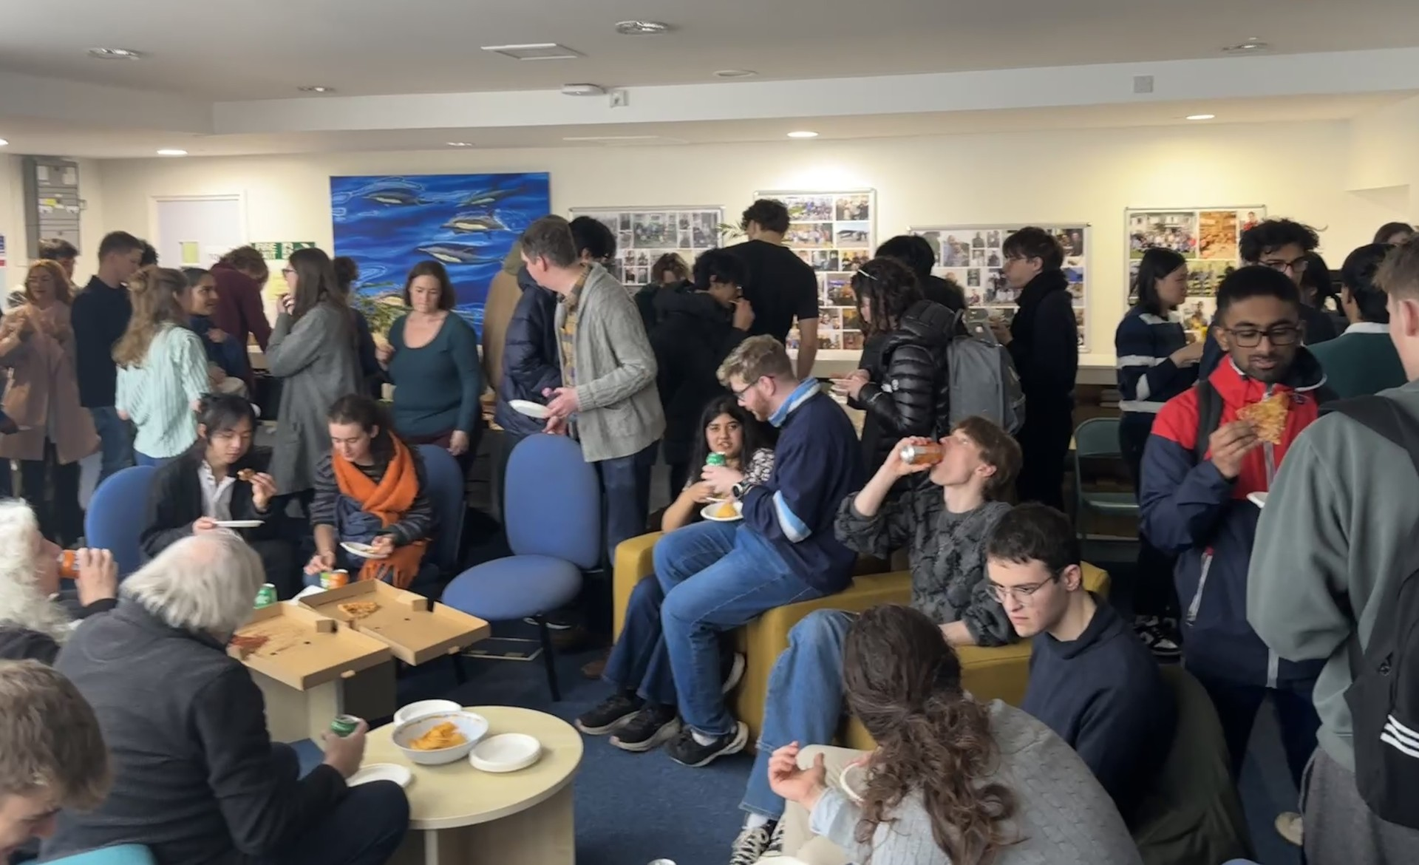
Pizza break at the student research conference
• On 17th March, honours students presented their research in the format of eight minute lightening talks at the MT173 Research Conference hosted at the Observatory by the Student President, Donald Campbell. For most speakers this was their first experience of presenting their work and they showcased their enthusiasm for research in a range of mathematical and statistical areas. The conference attracted over 50 guests and 10 student speakers.
• Alexander Russell attended the Magnetic Reconnection 2025 (MR2025) conference at Princeton from 10-14th March where he gave a talk on ‘Flux-rope-mediated turbulent magnetic reconnection’.
• Tom Elsden and Jimmy Brooks attended the Spring MIST (Magnetosphere Ionosphere Solar Terrestrial) meeting in Leicester from 7-9th April at which Tom gave a talk on the ‘Theory and modelling of plasmapause surface waves’.
• From 17th-21st March, Daphné Lemasquerier attended a conference Parameterizations for Global Dynamical Models in Climatology, Astrophysics, and Planetology at Les Houchs, near Chamonix in the French Alps, where she gave a talk on a quasi-linear model for zonal flows emergence and equilibration. Free afternoons were great for skiing and winter hiking! Then on 1st April, Daphné gave the Applied Mathematics Seminar at the University of Bath on ‘Turbulent zonal jets on giant planets: Self-organization and wave-mean flow interactions’.
• Danielle Harris and Gabrielle Arrieta from CREEM attended a one day workshop Ocean Bottom Geophysics: Progress and Perspectives at the Royal Astronomical Society in London on 14th March. This brought together groups from academia and industry who use oceanic seismic instruments to investigate a range of multidisciplinary questions. In particular, the instruments record the calls of large whales and the data can be used to estimate whale population sizes. Gabby extended her visit to London to meet with Ana Ferreira and her group at University College London to discuss data sharing and analysis.
• On 24th March, Rosemary Bailey gave an online lecture on ‘Design of experiments: An overview’ to statistics students at McGill University, Canada.
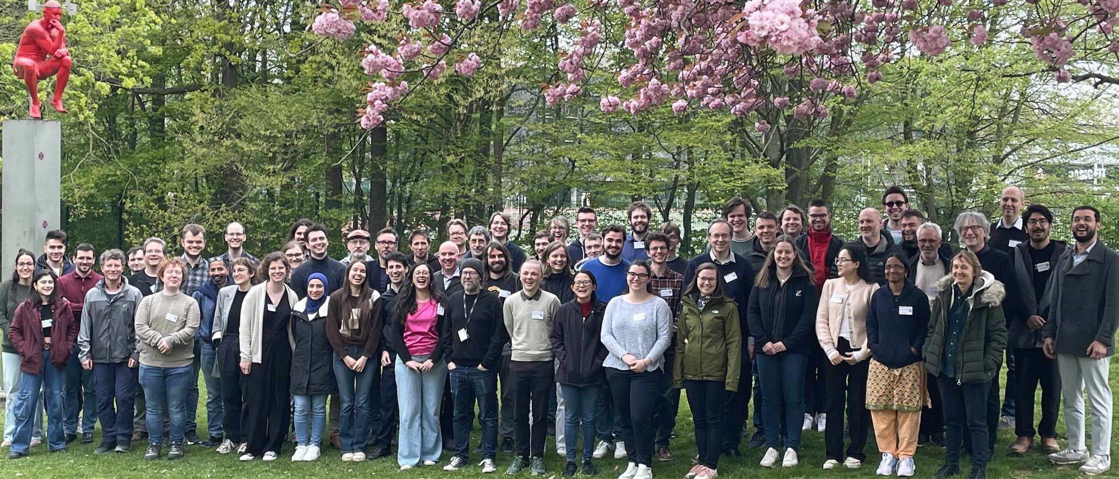
GAP Days at the Vrije Universiteit Brussel
• Reinis Cirpons, Joe Edwards and James Mitchell travelled to the Vrije Universiteit Brussel in Belgium to attend the GAP Days meeting between 7-11th April. The meeting drew attendees from 29 international institutions, and facilitated minicourses and development sessions to influence and contribute to the future of the GAP (Groups, Algorithms, Programs) programming language.
• On 24th March, Jeff Hicks gave a talk ‘Weinstein Neighborhoods under HMS’ (HMS = Homological Mirror Symmetry) in the Sheffield Algebraic Geometry and Mathematical Physics seminar. Then between 7-11th April he visited the Oberwolfach Research Institute for Mathematics in the Black Forest, Germany, for the workshop on Toric Geometry where he gave a talk titled ‘Resolutions in topology, symplectic, and algebraic geometry’.
• Violeta López presented a seven minute talk titled ‘Tropical curves that are Brill-Noether general’ at the workshop Combinatorial Algebraic Geometry: Highlighting Underrepresented Genders, held at Goethe University Frankfurt am Main, from 31st March-4th April.
• On 8th April, Jon Fraser and Ana de Orellana organised an afternoon workshop as part of the Harmonic Analysis and PDEs network, which has been funded by an LMS Scheme 3 grant since 2005 and has nodes in 10 institutions in the UK and Spain. The workshop was attended by 21 mathematicians with four speakers: Jonathan Hickman (Edinburgh), Ana de Orellana (St Andrews), Firdavs Rakhmonov (St Andrews) and Jakub Takáč (Warwick).
• Firdavs Rakhmonov delivered a talk at the Online Conference on Combinatorial Number Theory and Connected Topics (CONTACT-IV) titled ‘Exceptional projections in finite fields: Fourier analytic bounds and incidence geometry’ based on a joint paper with Jon Fraser.
• Ana de Orellana gave a talk at the Young Functional Analysts Workshop in Glasgow, which took place from 2nd-4th April.
• Mike Todd visited the University of Porto during Independent Learning Week to work on problems in dynamical systems and extreme value theory with Ana Cristina Freitas and Jorge Freitas. Mike also gave a talk in the Dynamical Systems Seminar on ‘Countable Markov shifts with exponential mixing’.
• Coen del Val, Colva Roney-Dougal and Hongyi Huang went to an Oberwolfach workshop on Finite Groups, Fusion Systems and Applications from 16th-21st March, all three giving talks.
• Colva Roney-Dougal travelled to the University of Coimbra in Portugal to give a colloquium talk on 9th April. Whilst there she was given a tour of the Juanina Library, one of the few libraries in the world to have a (deliberate) resident bat population.
• Theodor Thorbjornsen, Yayi Zhu and Jung Won Cho (Cho) attended the conference Introduction to Modern Advances in Algebra 2025 at the University of Manchester from 9-11th April. Yayi gave a talk on ‘Relational depth of transformation semigroups and their ideals’ and Cho spoke about ‘Howson property for monogenic inverse monoids’. All stayed on in Manchester to attend the 37th North British Semigroups and Applications Network (NBSAN) meeting on 11th April. Callum Barber and Murray Whyte also joined this meeting.

Other News
• The Pint of Science Festival is back in St Andrews on 19th-21st May 2025! Join our fantastic researchers at Sandy’s bar (inside the Union) as they share a unique line up of talks, demonstrations and live experiments held in a relaxed and informal environment. This year we’re exploring the latest in AI technology, delving into social technologies, and discovering the mysteries of shape in our universe – there is something for everyone! Visit the website for ticket links: pintofscience.co.uk.
• Former undergraduate Mia Tackney (graduated in 2015), who now works in the Medical Research Council’s Biostatistics Unit at the University of Cambridge, has been awarded a five year research grant from the NIHR (National Institute for Health and Care Research).

Next Issue
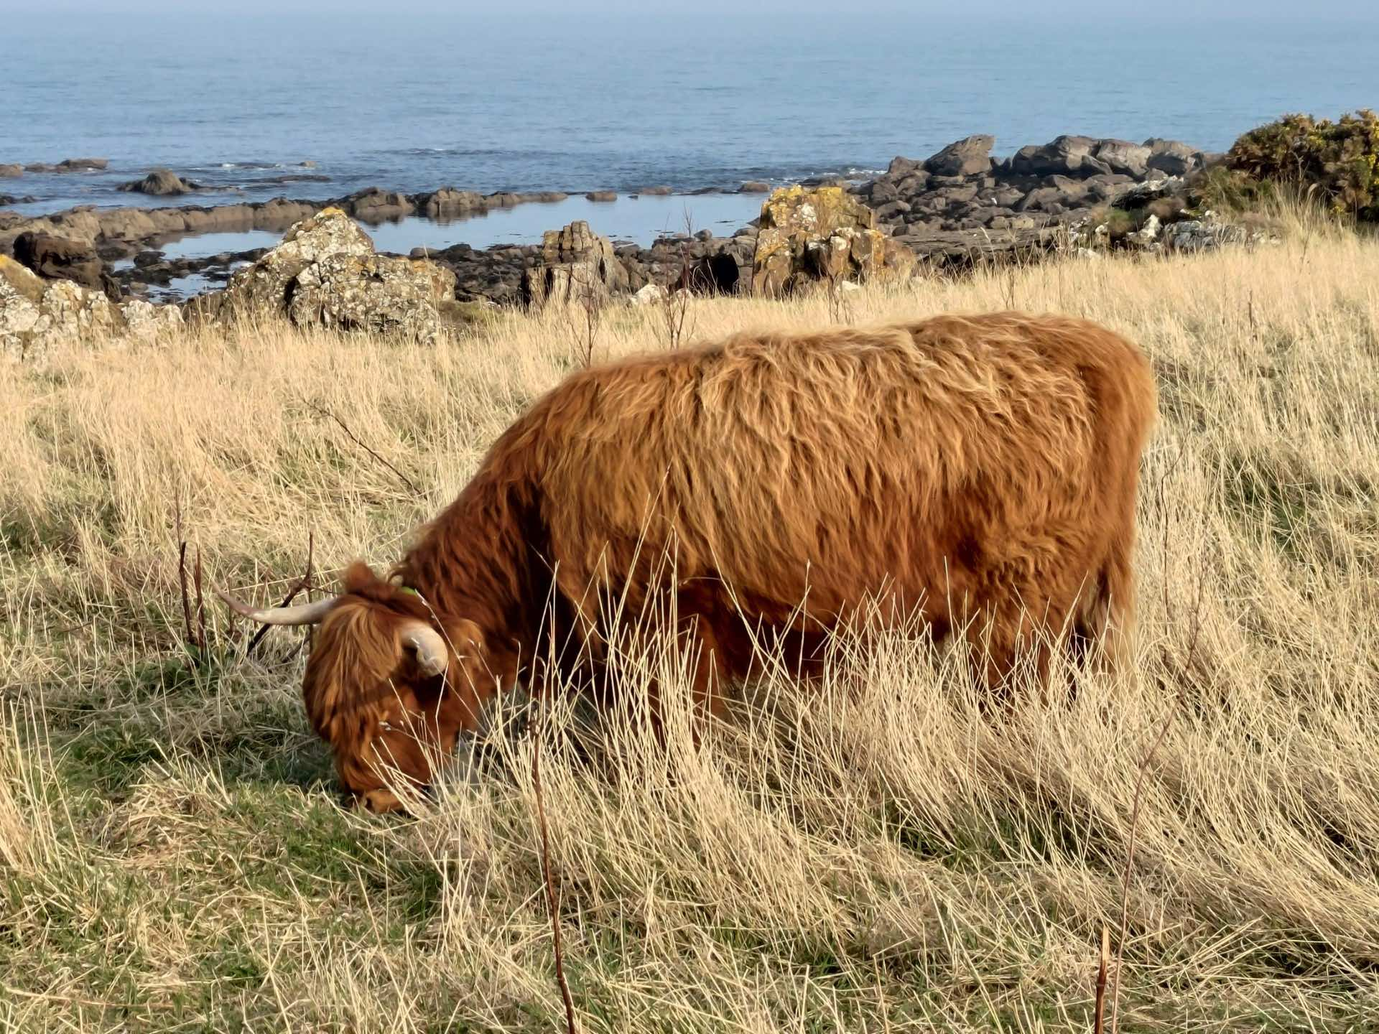
• The next edition of the School Newsletter will be circulated in May. Items may be sent to maths-news@st-andrews.ac.uk at any time but a reminder will be sent out a week before the deadline.
Encountered by Mike Todd on the Fife Coastal Path

