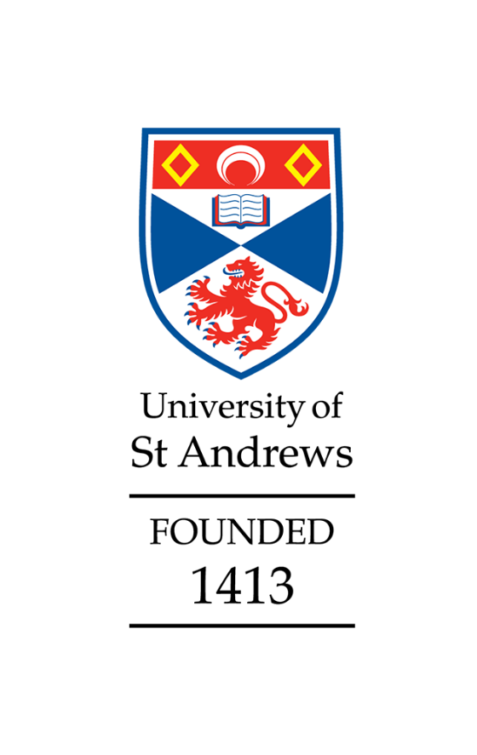

**School of Medicine**

Athena Swan

Silver application

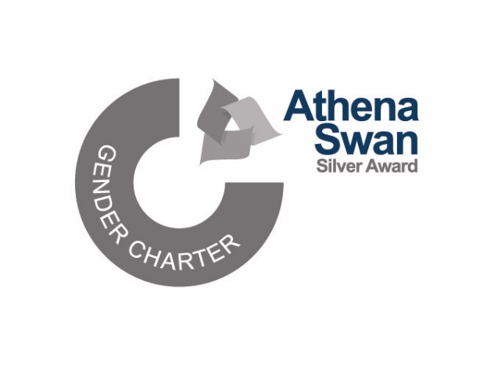

Awarded with minor revisions (Criteria B)

March 2023

**Applicant information**

|  |  |
| --- | --- |
| Name of institution | University of St Andrews |
| Name of department | School of Medicine |
| Date of current application | 30 September 2022 |
| Level of previous award | Bronze |
| Date of previous award | 28 April 2017 |
| Contact email | [meddi@st-andrews.ac.uk](mailto:meddi@st-andrews.ac.uk) |

### Table of Contents

Applicant information 1

Section 1: An overview of the department and its approach to gender equality 2

1. Letter of endorsement from the head of the department 2

2. Description of the department and its context 4

3. Governance and recognition of equality, diversity, and inclusion work 7

4. Development, evaluation and effectiveness of policies 11

5. Athena Swan self-assessment process 12

Section 2: An evaluation of the department’s progress and success 16

1. Evaluating progress against the previous action plan 16

2. Evaluating success against the department’s key priorities 19

Section 3: An assessment of the department’s gender equality context 22

1. Culture, inclusion and belonging 22

2. Key priorities for future action 31

Section 4: Future action plan 35

1. Action plan 35

Appendix 3: Glossary 51

### Notes

* **CAP** and **NAP** refer to our ‘current’ 2017-2022 and ‘new’ 2022-2027 action plans.
* A1 and A2 prefixes indicate table/chart numbers in Appendix 1 and 2.

# Section 1: An overview of the department and its approach to gender equality

## 1. Letter of endorsement from the head of the department

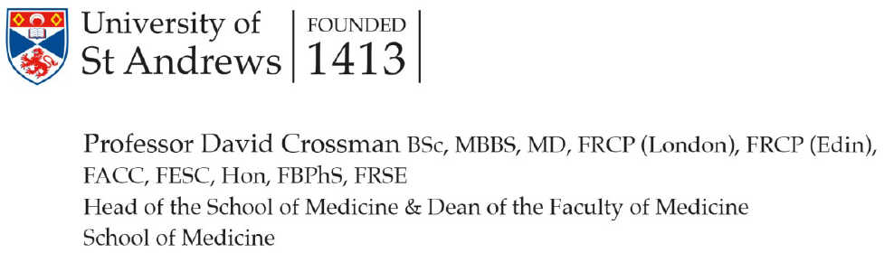

Athena Swan Charter

Advance HE

Innovation Way

York Science Park

York

YO10 5BR

30th September 2022

Dear Athena Swan Manager,

**Re: Athena Swan Silver Application, School of Medicine, University of St Andrews**

I write with wholehearted support of our Athena Swan Silver award application, to express my pride in our progress and express thanks to colleagues for their sustained efforts towards our gender equality vision by embedding the principles of Athena Swan in all School of Medicine (SMED) activities.

Since 2017 our refined Equality, Diversity & Inclusion (EDI) vision, reformed School structures and management and good HR principles have enabled delivery of EDI actions which have often pre-dated university level equivalents. EDI is emphasised throughout the staff and student journey. SMED’s staff induction includes EDI training. We introduced active-bystander training, and anonymous concern reporting systems. Our workload allocation model (introduced prior to the University requiring this for all schools) includes allocations for all academic staff to participate in EDI initiatives. Professional services (PS) staff have EDI written into workplans. We were one of the first schools to formalise the EDI lead role as a Director and have this within our senior management. EDI has administrative support and budget.

Our growing School has long-term plans for addressing inequalities especially the number of women at senior grades. We actively promote recruitment opportunities, both externally and internally. The latter has increased women in senior (Grade 6) PS posts. Recruitment of female professors remains a challenge which we continue to pursue but we will continue to support women to successfully apply for promotion to chair.

SMED activity in national EDI initiatives is valued. Led by SMED women, we are a founding member of Academic Intersectionality Mentoring in Medical Schools and co-chair of the Sexual and Gender-based Violence in Medical Education group. SMED has committed to implementing the British Medical Association’s Racial Harassment Charter and the UK Medical School’s Charter on Conversion Therapy, activities that support intersectional equality.

SMED’s pastoral support for students is exceptional. We are building gender-equality into the curriculum and are undertaking a curriculum review to further enhance this.

I am deeply committed to inclusion. Proactively removing barriers is a personal guiding principle. Via the Inclusion committee I enable my Director of Inclusion to lead with my full and visible backing. I ring-fence the EDI budget which has funded social gatherings, free wellbeing and sports classes, mindfulness, outside space and EDI research.

I can use my national roles at the Medical Schools Council executive and as Vice Chair of the Clinical Academic Staffing subgroup of University Colleges Employers Association (UCEA) to drive forward equality issues within the sector. Whilst Chief Scientist in Scotland, I initiated requirements for equality impact assessment on some awards and broadened inclusion in fellowship schemes for disciplines beyond medicine redressing gender inequalities.

Our AS action plan is our living template for the delivery of our gender and intersectional equality priorities and has my full support and that of my senior management team.

Yours sincerely,

PROFESSOR DAVID CROSSMAN

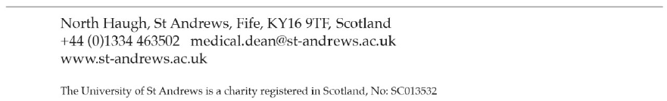

## 2. Description of the department and its context

The School of Medicine (SMED) is one of 20 Schools at the University of St Andrews and was ranked 5th in the Guardian and 11th in the Times & Sunday Times University Guides for UK Medical Schools (2023). 86% of SMED’s research programmes in molecular medicine, infectious disease, and population health sciences were deemed world-leading or internationally excellent in the REF2021. Additionally, SMED is involved in several cross-institutional centres and Institutes.

The undergraduate (UG) BSc Medicine pathway provides a grounding in medical science, integrated with clinical teaching. Students graduate after three years with a BSc Honours degree in Medicine, then move to a partner Institution for a further three years to graduate with a Bachelor of Medicine and Surgery (MBChB or MBBS) (Figure 1). SMED offers foundation programmes to support prospective undergraduates to enter the BSc course, widening access.

The Scottish Graduate Entry Medicine (ScotGEM) programme launched in 2018-19, in partnership with the University of Dundee, the University of the Highlands and Islands, and NHS Scotland. This four-year programme (Figures 1, 2) aims to develop general practitioners (GPs) to meet NHS Scotland’s demands and has a focus on rural medical practice.

Figure 1. Structure of School of Medicine undergraduate programmes and exit qualifications

Figure 2. The first cohort to graduate from the ScotGEM programme, June 2022

SMED offers two Postgraduate Taught (PGT) 1-year Masters programmes, MSc Health Psychology and MSc Digital Health, in addition to Postgraduate Research (PGR) study towards an MSc(Res), PhD, or MD qualification (Figure 3).

Pie chart showing the make-up of the current SMED community, including:
- UG students (75%)
- PGT students (2%)
- PGR students (5%)
- Professional services staff (6%)
- Academic staff (12%)
Figure 3. Current SMED community

Squares of colour showing which portions of the pie chart correspond to which student or staff group.

UG Students (636 | 63%F:37%M)

PGT Students (14 | 50%F:50%M)

PGR Students (42 | 46%F:54%M)

Professional Services Staff (54 | 74%F:26%M)

Academic Staff (97 | 48%F:52%M)

The School building (Figures 4, 5) shares a campus with the Schools of Physics, Chemistry and Biology, supporting integrative research and teaching. There are open communal areas in the building for studying and socialising, which also provide space for showcasing recent achievements, and for communicating activities including wellbeing initiatives. These shared spaces help foster a welcoming and inclusive environment; our 2020 survey showed that 78% of respondents (86%women:76%men) agreed that the School creates a welcoming environment (Figure A1-1.8), and the General Medical Council reports have noted the School’s collegiate atmosphere.

Figure 4. Students practicing in clinical skills suite

Figure 5. Courtyard of the School Building where communal spaces and medicinal herb garden are located



Of note since receiving our Athena Swan (AS) Bronze award in 2017:

* All academic staff assigned to one of four new Academic Divisions (2017): Cellular Medicine (CM), Education (EDU), Infection and Global Health (IGH), Population and Behavioural Science (PBS).
* Increase in education-focused staff numbers to support ScotGEM.
* External consultation exercise undertaken (2019) to identify priority areas to develop School culture.
* Governance and managerial format restructured in response to consultation.
* Launch of Mackenzie Institute, SMED-led cross-school initiative (2019).
* Covid-19 adaptations, including providing both online and in-person clinical teaching, flexible remote-working, access to research facilities, and supporting staff with additional responsibilities such as caring for dependents.
* Signatory to the British Medical Association (BMA) Racial harassment charter for medical schools (2020).
* Professional Services function review (2020) resulting in reconfiguration of ~50 roles.
* 2021-2026 School strategy published (2021).
* Wellbeing Officer role established.
* Signatory to the UK Medical School Charter on so-called ‘Conversion Therapy’ (2022).

## 3. Governance and recognition of equality, diversity, and inclusion work

World-leading, Global, Entrepreneurial, and Diverse are the central strategic themes at St Andrews. The Vice-Principal (People & Diversity) overseas the delivery of the Diverse St Andrews activity and Chairs the Central EDI Committee. Schools, including Medicine, are represented at this committee by two Faculty Leads, who in turn work with School EDI Leads to share practice and information. This structure enables EDI issues and concerns to flow from centre to school and vice versa (Figure 6).

Figure 6. Information flow from University to School

EDI is similarly embedded in the School’s 2021-2026 strategy. The SMED vision statement is:

*“The School of Medicine will be an outstanding place to work, study and collaborate where the principles of fairness and opportunity are fully embedded in our philosophy and operations and that our School and University are recognised internal and externally as a sector leading progressive, inclusive, and fair practice and opportunity institution. Where all colleagues feel supported, valued, and able to speak out and where bias, bullying, discrimination, and harassment are not tolerated.”*

Our 2022 School survey indicated that, among staff, 79% of men and 77% women agreed/strongly agreed that “Equality, Diversity & Inclusion are a priority within the School”; a dramatic increase from the 2020 survey where 65% women agreed with this statement (men were 80% in agreement). Students also showed an increase in this question from 51% (2020) to 59% (2022) (Figure A1-1.9)

The SMED is managed by the Operations (Ops) Group, comprised of senior representatives of the school. The student voice is feed into school business via Consultative Committees, and staff voice via School Council. A series of committees, including one with responsibility for EDI, manages the business of the School (Figure 7). Minutes of all committee meetings are available to all staff and students. School open fora (4-6 weekly, although increased to fortnightly during the pandemic) allows the Head of School (HoS) to give updates and staff to ask questions.

Figure 7 – School of Medicine Committee Structure (See Table A2-2.41 for information on composition by gender)

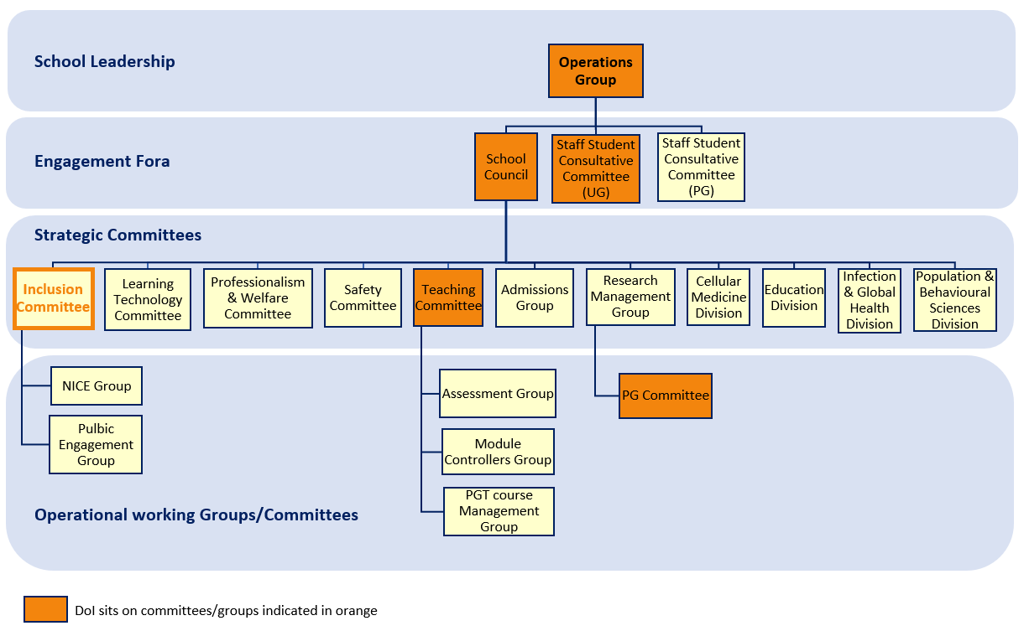

EDI governance and recognition within SMED has changed since our previous Athena Swan award. The SCALE (Strategy for Changing our Academic Life Environment) group has been replaced by an EDI Committee, and the more strategic Director of EDI (DoEDI) replaced the EDI Officer role. The EDI Committee was given equivalent status to other strategic committees within SMED, and further changes include:

* + Director of EDI member of Operations Group
  + Terms of Reference developed
  + Head of School a core EDI Committee member
  + Members are ex-officio role holders, plus members representing groups within the School community, including honorary staff and students.
  + EDI Vision Statement created
  + Working Groups established:
    - Athena Swan – application submission, action plan
    - Integration - matters related to inclusion
    - Listening to Language - communication within curricula and the School
    - Review and Development - support for staff and students
    - Workplace Environment - community and events

To align with the 2021-26 School strategy, the EDI Committee was renamed the Inclusion Committee (IC), and Director of EDI became the Director of Inclusion (DoI). The Director of Inclusion’s role expanded to cover all EDI work within the School, including membership of School Committees (Figure 7), to provide EDI representation.

The Director of Inclusion is appointed via advertisement, application, and interview. Inclusion Committee membership is openly advertised in the School, with appointments made jointly by the Director of Inclusion and Head of School. Current Inclusion Committee members (16F:13M; 55%F compared to 61%F across school community) include colleagues without previous involvement in EDI activity. **(CAP2.1)**. The Director of Inclusion receives a yearly workload allowance of 330 hours, and Inclusion Committee members are allocated around one hour per week.

The Inclusion Committee has an annual budget of £3,000 for EDI activities, which has supported maintenance of the communal medicinal herb garden and provided wellbeing and exercise classes.

EDI is recognised within University promotion criteria as an element of Service and Leadership by “*making a sustained contribution to the development and achievement of the University’s equality and diversity objectives”.*

## 4. Development, evaluation and effectiveness of policies

Policies related to staff and students are developed at the institutional level. The university has a repository where all policy documents can be accessed. For staff policies, many (including leave and family-related policies) have a webpage with FAQs, plus a link where feedback can be submitted to Human Resources (HR) at any point. When a policy is reviewed (or a new policy developed), university-wide consultation is undertaken in accordance with the HR policy approval procedure. Consultation is promoted in newsletters and communicated to staff and students via the Heads of Schools/Units and EDI leads. Staff network groups (Parents and Carers network, staff with disabilities network, etc.) are also contacted. Feedback can be provided individually or collectively, for example the SMED Inclusion Committee has provided feedback on HR family-friendly policies. Policies related to learning and teaching are discussed at the University’s Learning and Teaching Committee, of which the SMED Director of Teaching is a member.

Changes in university policy are communicated to the School through the Head of School, then onward to SMED Operations group members to communicate to their respective committees and divisions. Policy revisions are also communicated in Head of School briefings, School Council meetings and by e-mail. Schools may produce guidelines to support these policies. SMED guidance documents are accessible via the school’s online handbook, ensuring transparency and accessibility.

Each school has a dedicated HR Business Partner, who works with the Head of School to ensure policies are understood and correctly applied. Any staff member in the school can contact the HR Business Partner regarding policies.

Line managers are asked to complete the ‘*HR policies for managers*’ course run by the university **(CAP 4.4)**. Since 2017, 20 staff (12F:8M) have completed this training.

In the School survey, staff were asked whether “HR policies are implemented in a consistent way in the School”. In 2020 only 45% of men and 48% of women gave a positive response but this had increased to 65% of men and 71% of women in 2022, and with a notable decrease in the proportion of negative responses in all categories (Figure A1-1.12). This may be due to the concerted efforts in promoting relevant policies to staff to support them through the pandemic.

School-level policy is developed (from the suggestion of any member of School when a need is identified) and evaluated at committee level before being considered by Operations Group for approval. Policies are evaluated by the Inclusion Committee, and we consult with staff via various fora (e.g., focus groups, school council) to assess their effectiveness. For policies related to learning and teaching, student representatives are involved in policy development, evaluation and consulted on effectiveness (e.g., we enabled students to sit exams around religious observance so that they were not disadvantaged by policies). The SMED has also led on change to University policy with changes to Senate regulations to uncouple graduating with a BSc Medicine from progression to partner Institutions. Although only affecting a very small number of students, this change ensured students who found themselves unable to progress to clinical training via our partners (possibly because of significant health issues) could still graduate with the BSc qualification.

## 5. Athena Swan self-assessment process

### Self-Assessment Team

The Director of Inclusion chairs the Athena Swan working group (ASWG), which acts as the Self-Assessment Team (SAT).

Athena Swan Working Group membership (alphabetically by surname):

|  |  |  |
| --- | --- | --- |
| **Member** | **Role in School** | **Role in SAT** |
|  | Academic Research-focused staff  Fixed-term contract | Data discussion and examination.  *Early Career perspective* |
|  | Dean of Medicine/Head of School  Clinical Academic Research and Education staff  Professor | Data discussion and decision guidance for submission.  *Senior leadership perspective* |
|  | Professional services staff | Data discussion, analysis of previous action plan, key role in action plan development.  *Professional services perspective* |
|  | University Equality & Diversity Awards Adviser  Professional services staff | Consultation throughout process, reading drafts, guidance as to direction and content. |
|  | Academic Education-focused staff  Lecturer | Previous DoEDI, section groundwork and initial data collection. Consulted on action plans, previous and new, reading drafts, appendix presentation format  *Lecturer perspective* |
|  | University Human Resources Business Partner  Professional services staff | Consulted on policy and implementation, as well as on logistical areas such as data labelling and storage.  *School-specific Human Resource perspective* |
|  | Academic Education-focused staff  Senior Lecturer | Consulted regarding progress, reading drafts and line managing AS Editor.  *Senior Lecturer perspective* |
|  | Academic Research and Education staff  Lecturer | Data discussion and examination.  *Early Career perspective* |
|  | Professional Services staff  School Manager | Key role in major decisions regarding submission, data discussion, analysis of previous action plan, key role in action plan development.  Senior leadership perspective |
|  | Academic Research and Education staff  Professor | Data discussion, analysis of previous action plan, key role in action plan development.  *Professor perspective* |
|  | PGR student - Part-time (0.5 FTE)  Employee - Part time (0.5 FTE) | **Athena Swan Editor**  Progressed and wrote substantial components of submission. Liaised on behalf and with ASWG until DoI appointment, data analysis, action plan analysis and write up.  *PGR perspective* |
|  | **Director of Inclusion**  Academic Education-focused staff  Senior Lecturer | **Chair**  Wrote substantial components of submission. Liaised on behalf and with ASWG, data analysis, action plan analysis and write up. Planned surveys with HR.  *Senior lecturer & leadership perspective* |

Figure 8 – Representation of self-identified characteristics on the ASWG

Nine members of the Athena Swan Working Group are members of the Inclusion Committee. The self-assessment is further supported by the university Planning Unit who annually provide data on SMED staff and students.

To ensure transparency, in line with our school vision, information about the work of the are available in the online SMED handbook and School website.

### Self-Assessment and application preparation

Work towards this application began in 2019, then aimed at submission in November 2020 (this being a one-year extension agreed by Advance HE to allow the changes to school structures to embed). The deadline subsequently moved to 2022, due to changes to award length in the transformed Charter and extensions for Industrial action. These deadline changes, as well as the changes in EDI governance (see section 1.3), coupled with the Covid-19 pandemic and introduction of the transformed charter, the School has had to rethink its approach to, and plans for, the self-assessment and application preparation several times.

After the Director of EDI’s absence (Figure 9) and before the appointment of the Director of Inclusion, Operations Group approved a 0.5 FTE fixed-term ‘Athena Swan Editor’ role to support the progression of the application. This role was filled by a PGR student who utilised the salaried role to support their studies, while gaining additional skills and experience. Upon appointment, the Director of Inclusion assumed lead responsibility for the application, with support from the Athena Swan Editor.

The self-assessment work was conducted via a mixture of group and one-to-one meetings and collaboration via shared online documents. Members of Inclusion Committee, which includes UG, PGT and PGR representation, and Operations Group have had input into the Athena Swan application.

Additionally, the application draft was reviewed by members of the University EDI Team who gave constructive feedback.

### Consultation

As part of its assessment of the gender equality context of the SMED, the Athena Swan working group (and Inclusion Committee as part of its wider EDI work) consulted with the school community in a variety of ways. Input was drawn from strategic committees and engagement fora, staff and student surveys, focus groups, structured workshops (within the external consultation exercise) and suggestion boxes. Athena Swan working group members served as points of contact for their representative communities.

Figure 9 – Timeline of activities related to application preparation and self-assessment described in application

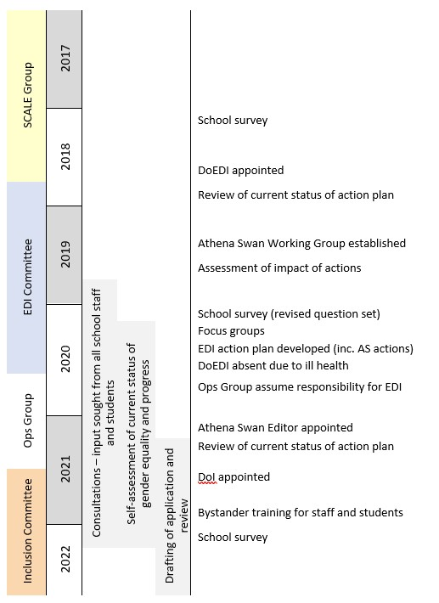

### Response to previous panel feedback

*Engage Professional Services staff in SAT:*  PS staff now represented on both Athena Swan Working Group and Inclusion Committee.

*More proactive actions to increase the proportion of female applicants to recruitment:* Recruitment agencies employed to specifically identify and target women applicants for our vacant positions.

*Improve perception of appraisal:* New review and development process in place with positive response from 77-83% in 2022 survey (up from 65% in 2017 Athena Swan application)

### Plans for the future of the self-assessment team

The Athena Swan Working Group will remain a sub-group of Inclusion Committee and meet twice per semester. The action plan will be reviewed at each Athena Swan Working Group meeting, managed by the Athena Swan coordinator **(NAP5.1),** with an annual report on progress presented at Inclusion Committee. A major review of the action plan, including school-wide consultation, will be undertaken at 2-year intervals during the award period.

Athena Swan Working Group membership will be reviewed annually, with maximum term of 3 years, to facilitate turnover and ensure participatory opportunity for colleagues. New members will be sought from Inclusion Committee and by open advertisement to the School community.

# Section 2: An evaluation of the department’s progress and success

## 1. Evaluating progress against the previous action plan

Although the action plan was written under the former charter when identifying key priorities was not required, retrospective key priorities are marked by ‘**’.

Throughout the application text, action numbers are prefixed with ‘**CAP**’ to indicate that they refer to the 2017-2022 ‘current’ action plan.

Figure 10. Summary of RAG rating of 2017-2022 Action Plan

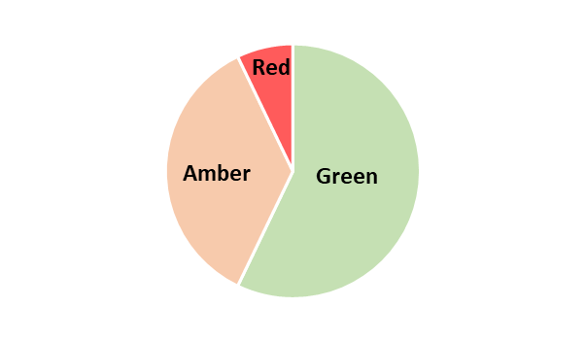

### Methodology of action implementation

The changes in School EDI governance (see section 1.3), impacted the implementation of the 2017 Bronze award action plan, and led to the adoption of a maintenance rather than active approach.

The Covid-19 pandemic has created further challenges in being able to maintain and analyse datasets (**CAP3.2, CAP4.6 | Research and Fixed-term staff**). Many researchers were furloughed and, when reopened, the number of staff in laboratories was tightly regulated. Charity funding reduced drastically which made it more difficult to maintain funding and therefore postdoctoral positions.

A promotion round did not take place in 2020 which directly impacted on progression of **CAP4.1** (Senior women)**, although we are getting back on track with the 2021 promotion round (Table A2-2.38).

### Reflecting on amber and red action – main barriers and facilitators to action implementation

Progress has been made on **CAP3.1 (Clinical staff data)**, but this complex action is not yet complete. A major barrier is the complexity of clinical teaching staff grading with different employment roles by the university for NHS-bi-institutional contracts and NHS-only contracts (e.g., General Practitioners who teach in the school). These varied roles are difficult to capture when colleagues are not employed by the university, thus not registered in a standardised way in HR databases. Thus, it is difficult to tag “clinical” and “non-clinical” staff, beyond pay scales, as used in this application. The University is in the process of procuring a new database system for staff records. We will therefore continue this action **(NAP5.2)** and work with HR to ensure that SMED staff can be usefully categorised within the new system to enable us to better understand any difference in the experiences of staff holding different contract types.

**CAP4.1** (Senior women)** saw SMED increase its activities around supporting internal staff to apply for advertised roles as well as progressing by promotion and regrading. This approach, where the expectation to identify and encourage potential internal candidates was clearly communicated to line managers, has seen the number of women in senior (grade 6) positions within our Professional Services staff rise from 43% in 2016 to 67% in 2021 (Table A2-2.27).  
  
For academic posts, the School has used executive recruiters to provide a diverse pool of applicants. We are aware that we have shortlisted very few women at grade 8 (senior lecturer/reader) or 9 (professorial level). Only [<5] candidates were shortlisted over 2018-2021 from 16 applications to these grades (Table A2-2.34). The School has invested 92% of its recruiting costs to ensure advertisements are targeted to potential women applicants and will continue to do so **(NAP2.1)**.

The School has increased its internal support structures (e.g., pre-promotion panels) to aid internal promotion to these grades. With increased opportunities and transparent process for leadership roles, our objective has been to enable female staff to position themselves to be competitive for promotion. In the past two application rounds have seen [<5] applications at these levels from women with 100% success, compared to [<5] applications from the three previous rounds with a 25% success rate (Table A2-2.38).

We want to develop our more junior recruitment **(NAP1.1)** and continue both internal promotion and external recruitment **(NAP2.1)**.

The 95% target for **CAP4.2** (EDI training)** was not reached. Participating in EDI and related training is important in creating an inclusive, diverse, and fair environment. Awareness-raising of EDI training has occurred in various fora. All new staff now receive an EDI induction as part of the school’s induction process and are directed to Institutional Diversity in the Workplace (equalities law) and Unconscious Bias e-modules.

In July 2020, SMED instigated a mandate that all staff complete EDI modules on a   
3-yearly cycle (going beyond the institutional requirement). The promotion of this new requirement will enhance communications of the importance SMED puts on this training and, we hope, will drive up engagement with the training overall from the current completion rate of 58% **(NAP3.2)**.

We have also added active-bystander training to our EDI training provision. The Director of Inclusion scoped active-bystander training and then subsequently lobbied for this training to be introduced at an institutional level. The SMED acted as a pilot for this training; with 40 SMED staff completing this training in November 2021. The reaction to this training from attendees was very positive:

*“An excellent event. Thought provoking and interesting. Lots of practical examples that we could all identify with.”*

*“This was an opportunity to learn more about what an active bystander is. I now feel empowered and supported by the School to be proactive in intervening in situations where I think it is necessary.”*

Students in Years 1-3 of our BSc (n=525) and Years 1-2 of our ScotGEM programme (n=111) completed this training during January–March 2022.

The SMED asks all honorary staff to report what EDI training they have done in their own organisations (NHS or other). We ask for evidence that they have completed EDI training and anyone who has not is asked to complete the university EDI modules.

**CAP4.8 (Women on external committees)** The School encouragedmembership of external committees and facilitated participation by workload allocation and financial support to travel to committee meetings. However, participation in external committees is difficult to track (and time consuming as it is done within the School). Furthermore, the University has deprioritised membership of external committees by not asking for this in the workload model. As a result, the formal monitoring of this action has been discontinued.

Line managers continue to encourage membership of internal committees, with relevant opportunities being widely advertised in the School. Women make up at least 37% of all school committees/groups (Table A2-2.41).

### Main learnings and outcomes

It has become clear while reviewing our action plan that there are gaps in data collection that need to be addressed and that our NAP needs to have more measurable outcomes. The implementation of our action plan has been made more difficult by needing datasets that are not routinely collected and analysed and further impacted by factors such as role recognition by central university and administrative workload to staff for collecting school-specific data. While the SMED is taking steps to address these issues, a more progressive, sustained action may be needed **(NAP5.1).**

**Affected actions: CAP3.1, CAP3.2, CAP4.6, CAP4.8, CAP4.9**

**New actions: NAP3, NAP5**

## 2. Evaluating success against the department’s key priorities

The SMED is committed to supporting and encouraging the careers of women. We see a decline in the proportion of women within our populations from UG student, through to academic grade 9 posts (Figure A2-2.1). Since our Bronze award was submitted in 2016, we have been working to address this inequality, through promoting mentoring initiatives, celebrating the achievements of female staff as role models, and ensuring that women are represented in leadership roles.

We encourage our female staff to be visible role models, in ways they feel comfortable doing so.

**ü** SMED staff have featured in campaigns to promote the viability of academic careers to women (Figure 11), including the Royal Society of Edinburgh’s 2018 Women in Science Scotland exhibition and the University of St Andrews 2017 Academic Women Here! publication. The latter highlighting career/life stories to show there are many ways to have a career in academia.

Figure 11. Female staff members featured in institutional and national campaigns. Left: SMED staff included in University of St Andrews Academic Women Here! publication. Right: Tweet promoting Royal Society of Edinburgh Women in Science Scotland exhibition

Mentoring initiatives are an important element in giving female staff the tools to take on leadership positions and advance their careers.

**ü** For academic staff, the university has a cross-institutional scheme (TRAMS, Teaching Research and Academic Mentoring Scheme). At the point of our Bronze application, [<5] staff were mentees in TRAMS. We have worked to promote this scheme **(CAP4.5**)** and during 2016-2020 have had 17 (12F:5M) TRAMS mentees (Figure A2-2.3). Furthermore, when asked about mentoring in our 2020 school survey (Table A1-1.3), 42% of women (compared to 14% of men) reported that they had taken part in a mentoring scheme in the past 2 years (either as a mentee, mentor or both).

Advance HE’s Aurora programme is actively promoted to women in the SMED, via noticeboards, e-mails and Open Fora, and line managers are asked to encourage female staff to apply.

**ü** Since 2017, 15 female staff (academic and Professional Services) have completed Aurora.

**ü** Since completing Aurora our staff have taken on Director/Head/ProDean roles; successfully applied for promotion; held management roles on a School Committee; moved to more senior positions at other UK universities

Aurora participation has been universally considered a positive experience by those who have taken part:

*“Aurora gave me the time and space to reflect on my own leadership experiences and possibilities. It enabled me to better recognise my achievements and skill set. The best part was my mentor. She challenged my thinking and helped me reflect on my insecurities around me as a leader. Aurora has helped me be more confident in my leadership abilities and has had a huge impact on my thinking.”*

*(Aurora participant)*

*“I found Aurora extremely beneficial. It gave me the opportunity to consider and foster leadership skills, amongst a diverse group of supportive participants. I really valued the dedicated time to reflect on my career direction/progression, alongside the mentorship support”.*

*(Aurora participant)*

*“I saw the opportunity to apply for a fully-funded place advertised and my line manager encouraged me to apply.* *I felt that the programme would be of benefit for the new leadership roles within the school that I had taken on. Aurora made me reflect on the fact that you don't have to have a leadership or managerial role to demonstrate leadership. I realised that I had demonstrated these skills through previous work and initiatives where I had influenced change or made a difference. The programme changed my mind set and perspective, increased my confidence at work and motivated me to value the personal attributes that I have as well as my professional skills.”*

*(Aurora participant)*

Another important provision is the peer support and networking opportunities offered by networks. Instigated and run by staff, the University has a Women in Science at St Andrews (WISSA) network open to all levels of academic staff, from researchers through to Professors.

**ü** [name removed] (Figure 12) is SMED’s current WISSA Champion and helps organise events and promote the network to other SMED staff.

Figure 12. Tweet celebrating SMED’s Women in Science at St Andrews Champion (image removed)

A screenshot of a social media post.
Text at the top announces the SMED representative for WISSA. A photograph below shows the head and torso of a woman wearing a black top with a backpack. She is looking directly at the camera and smiling. The background shows a rocky coast, the sea and a blue/orange sky as the sun sets.

Enabling flexibility in working arrangements supports our staff with caring and other responsibilities as well as maintenance of a healthy whole life balance and has been an area of interest for the School **(CAP4.10**)**. In the 2021 University survey, 89% of respondents from SMED indicated that flexibility in their working arrangements was important to them.

**ü** In the past 6 years, the number of staff having formal flexible working arrangements agreed has increased (Table A2-2.49), particularly among female staff.

Coupled with our various initiatives to support and encourage women, there has been a demonstrable improvement in the representation of women in leadership roles in SMED and at middle grades (Table A2-2.14).

**ü** Within the 161 roles in the School covering leadership, committee membership, and programme and module co-ordination, we have seen a 57% increase in the proportion of women in these roles (Figure A2-2.3).

**ü** The proportion of women in grade 8 academic education-focused roles has increased from 25% in 2017 to 50% in 2021

**ü** The proportion of women in academic research and education roles has increased:

* from 60%in 2017 to 75% in 2021 for senior lecturers
* from 0% in 2017 to 40% in 2021 for readers

# Section 3: An assessment of the department’s gender equality context

## 1. Culture, inclusion and belonging

The SMED has invested time and resources into ensuring, in a background of significant change (detailed in section 1), that a positive workplace culture is developed throughout the school that provides all members of our community a place to work and learn where they can engage with intellectual challenges while realising their own potential.

The School engaged an external company in 2019 to undertake a consultation exercise to identify priority areas to develop School culture. This involved a 2-day workshop and individual consultations with a diverse and representative cross-section of the school community. A variety of recommendations were made that led to the School restructuring its governance format, and drove how we embedded EDI across the school and within our strategic ambitions, as well as how the initial work of the EDI Committee was structured. Subsequently, our school surveys and other consultations have allowed us to better understand how these changes are being received and identify further areas to continue to improve our school culture.

### Making SMED a welcoming and supportive place to work and learn

The SMED aims for a working environment that is open, approachable and inclusive.

Achieving this aim starts from the beginning of an individual’s engagement with the School. EDI is part of induction for both staff and students. Like staff, students are required to complete an e-module on equality law.

New staff are allocated a “buddy” who provides first contact and general peer support. On their first day, the new staff member has a tour of the facilities and is taken to lunch (facilitated by EDI budget) by their buddy. An email is sent to all SMED staff introducing the new staff member, linking to their biography, optional photograph, and role details.

During remote working for Covid-19, these activities were facilitated online. There was a fear that this could have impacted the feeling of connectedness to the school community, but feedback has been very positive:

" *I was overwhelmed by the amount of people who responded to my welcome email by introducing themselves and arranging an introductory Teams meeting. Despite me coming to the school during lockdown and not meeting any of my colleagues in person for the first six months, the school instantly made me feel like a valued member of the school."*

(Staff member, 2021)

When the buddy system was established, buddies were typically those in a related role. We have started to assign buddies from both within and outside a new start’s field to support school-wide integration.

Transparency is a key element of a positive culture. In SMED we have a, widely advertised and used, online handbook, accessible to all staff and students, containing information on school policies and procedures and committee memberships. Records of School business including meeting minutes are available via the School Intranet. Additionally, we share information through emails, staff meetings and line manager updates. There was a high positive response to school survey questions related to finding information, higher than 90% for some groups (Table A1-1.5)

Through our Inclusion Committee working groups we have revised our communications in response to some negative perceptions in this area identified in the external consultation exercise. Our main method of communication of current activity is via the School Newsletter, which goes to all staff (including honorary staff) and celebrates individual successes from promotions, publications and grants through to fundraisers.

“*It makes us feel more of a community*”

(Staff member)

The externally-facing website is also an important communication vehicle. The EDI content will be further developed **(NAP3.1)**.

Working remotely can be disjointing for some and the School leadership was particularly mindful of this during Covid-19, supporting varied ways to reach out to our community. One example was the Instagram feature, Saints of St Andrews Medicine, which showcased our staff to rekindle community connectedness. With 900 followers, our page reaches across much of our community:

*“Seeing the activity and background of members of my school has showcased inspirational female role models for me and made the community feel more accessible”*

*(PGR student)*

Figure 13. Instagram post featuring one of the school members based in Nairn (Scottish Highlands) for ‘Saint of St Andrews Medicine’ feature with 75 ‘likes’. (image removed)



Positive responses by SMED staff to the university survey question “I feel a strong sense of belonging to my School/Unit” (88%M:68%W) gives an indication that our activities and actions are generating the positive culture we desire, but there is still much room for improvement.

### Making SMED an inclusive place to work and study

The Medical School Building includes a variety of features to make it a welcoming and inclusive space, facilitating socialising and networking among our community. Such interactions complement the professional engagements, and support staff and student wellbeing.

The ground floor includes a café and large seating area which is a hive of activity and acts as the main social space for students. The café looks onto and opens into the courtyard that contains the medicinal herb garden. This is actively maintained by several colleagues, with upkeep supported by the Inclusion Committee.

The building is fully wheelchair accessible, and there is at least one accessible toilet on each of the three floors. There are several gender-neutral toilets throughout the building. We have a dedicated nursing room for breast-feeding, available to both staff and students, which has a fridge for storage of expressed milk and a bottle steriliser. Dedicated prayer space is advertised and is available in a nearby building a 5-minute walk away.

The School operates core meeting hours (10am-4pm) to allow those with family and/or caring commitments to be fully engaged with the life of the School on an equal basis.

In our 2020 school survey (Figure A1-1.16), 75%M:79%W strongly agreed/agreed to the question ‘Core activities like events/meetings are scheduled during School core hours’. However, in 2022 this reduced to 64%M:68%W. All committee/group meetings are arranged centrally, so we know that they are in core hours. During Covid-19, staff have been working more flexible hours to accommodate their needs, so other types of meetings may have similarly been scheduled more flexibly giving this perception.

Inclusivity of teaching is important to us. Recent improvements in this area include:

* Purchased more representative clinical models for use in our clinical skills suite (Figure 14).
* Revised core reading list to include ‘Mind the Gap’ dermatology textbook that explains how to diagnose skin conditions on different skin tones.
* Additional teaching on sexual based violence, menopause, pregnancy loss.
* Embedded diverse case stories and examples into teaching.
* Diversifying our simulated patient and patient partner lists, so students receive a wider experience across intersectionality of gender, ethnicity, and age.
* Introduced lectures on ‘What is normal’ and ‘Decolonising the curriculum’ to challenge students to consider and challenge conventions.
* Provided training for staff on digital accessibility of learning resources.
* Encouraged pronoun use by staff and students.

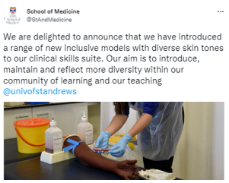Figure 14. Tweet promoting SMED’s clinical models with diverse skin tones

### Ensuring staff and students have a voice in the School

85%M:82%W strongly agreed/agreed that their contributions are valued in the 2022 school survey (Table A1-1.2). Supporting feelings of ‘value’ is how people feel their voice is heard in the School, either that their suggestions are listened to, or that, if they choose, they can have a role in decision making.

As part of the changes resulting from the external consultation exercise, and the Professional Services staff review, a Change Champion group was formed. Following consultations and information sessions, the group drafted a set of ‘seed’ behaviours for the School:

A community that listens and cares

Understand and value contribution

Communicate openly and honestly

We trust and support each other

Encourage development

This group, latterly called the Continuous Improvement Group, developed a set of infographics (Figure 15) to illustrate the key feedback channels that School members had available to them to make suggestions for improving the School culture.

Figure 15. ‘What do we do with a new idea’ infographic developed by the Continuous Improvement Group illustrating how feedback is processed.

Despite these efforts, disappointingly, in the 2021 University survey only 57%M:52%W strongly agreed/agreed with the statement ‘I believe that I can influence practice and policy in my School/Unit through voicing ideas and suggestions’ (Figure A1-1.13).

When leadership/committee roles have become available, the School issues an open call for expressions of interest, with applications from women and minority groups specifically encouraged. Advertisements include information on the role responsibilities and time allocation. Committee terms of reference are available in the online handbook for transparency.

### Supporting career development

For academic staff developing an application for promotion, SMED operates a supportive pre-promotions committee including senior staff and an external representative providing advice and guidance to improve applications. This is reflected in our school survey responses where there is an increase in positive responses around ‘the information available to me in advance’ (Table A1-1.4). We have particularly encouraged applications from women to senior lecturer and reader level as part of our ambition to develop professors internally and in the past two application rounds have seen [<5] applications to senior lecturer/reader from women with 100% success, compared to [<5] applications from the three previous rounds with a 25% success rate (Table A2-2.38).

Staff are encouraged to undertake training to develop their skills and knowledge. This may be externally, or from the vast suite that is on offer internally at the university. We examined the types of training that our staff attended between 2016 and 2020 (Figure A2-2.4), noting differences between different types of role – for example, education-focused staff attended more ‘teaching and assessment’ training. PS staff were the most likely to take training related to ‘working with others’. In school surveys more than half of respondents report that they found training effective in achieving their personal/professional aims, although a large proportion responded neutrally to this question (Figure A1-1.14).

Events the School has held to support career progression:

* Annual away day for Professional Services staff
* Fellowship day - providing researchers with information, support and advice for funding applications
* Explorathon: HERstory, 2021 –showcase research to an international audience. The School offered facilitated presentation practice for successful candidates.

We celebrate staff who gain recognition for their work, or complete further qualifications and promote non-standard career routes, both to raise awareness of these achievements as well as providing role models for others (Figure 16). We are pleased to offer workplace-based apprenticeships in the School. Our first apprentice is now working in SMED.

Figure 16. Tweets promoting staff achievements and available career routes   
(images removed)

In 2021, SMED became one of nine UK medical schools to co-found the Academic Intersectionality Mentoring in Medical Schools (AIMMS), and two SMED staff sit on the AIMMS Committee. This national initiative which connects women from minority ethnic backgrounds working in both clinical and non-clinical capacities is founded on the understanding that this intersection of identities is underrepresented in mentorships.

### Tackling behaviours that negatively impact our work and study environments

The SMED promotes a positive culture and actively communicates our expectations regarding behaviours that negatively impact this. Formal reports of bullying, harassment or discrimination are dealt with in accordance with our policies.

Launched in 2020, the University’s online Report and Support system allows staff, students or members of the wider St Andrews town community to report issues of bullying, discrimination, abuse, assault, or harassment of any sort, either anonymously or with contact details (Figure 17). Named reports are passed to an appropriate staff member to respond and offer support. All reports (named and anonymous) are systematically reviewed by the Heads of HR, Student Services and Wellbeing & Mediation to identify ‘hot spots’ of behaviours and agree appropriate action. Periodic summaries of the types of reports received and the action taken are made available at the Report and Support website.

Figure 17. Screenshot of Report + Support site showing easily accessed reporting function at the top and some of the extensive support resources below

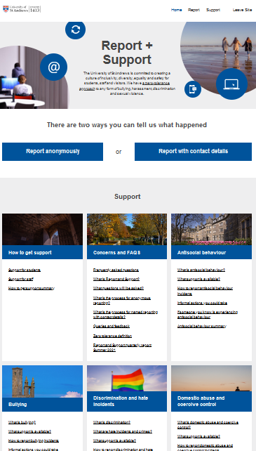

SMED has its own student voice platform for students to raise concerns about learning experiences that impact on them, or concerns related to patient safety. They can report with contact details or anonymously. Students can also raise issues directly to a member of staff. All concerns are logged, investigated, and outcome feedback reported back to student where contact details are available.

The 2022 school survey showed women within the School felt less comfortable raising concerns (strongly agreed/agreed response from 86%M:64%W staff and 75%M:62%W students) (Table A1-1.17). The University survey responses showed that only 52% (50%M:52%W) of staff were aware of the Report and Support tool, which we will be looking to address **(NAP4.1)**.

The BMA racial harassment charter emphasises provision of guidance and training on how to challenge behaviour and active-bystanding. In response to this, SMED has committed to active-bystander training for all staff and students **(NAP4.1)**.

In addition to considering behaviours within the university, we also consider behaviours in settings outside of the university. Our agreements with Placement providers require all parties to sign a quality commitment including EDI. Our BSc GP Practice agreement was reviewed by Black, Asian and Minority Ethnic student representatives for compliance with BMA racial harassment charter, following which we added “Placement providers will take all reasonable steps to prevent harassment of students and provide support to students if they experience it.”.

An SMED staff member also co-chairs a national group working to tackle gender-based aggressions and violence in medical schools and associated organisations

### Supporting the maintenance of a healthy whole life balance

The wellbeing of our staff and students is important to us, and it is pleasing to note that this message is being heard by our community. In the 2022 school survey there was a strong positive response from students (at least 85% in all categories of respondents) to the question ‘The School has clear guidance on where to find support around issues such as health, wellbeing and welfare (pastoral support)’ (Table A1-1.5).

The school supports a variety of wellbeing activities (see Section 1), and the university also offers training and activities in this area. Since 2017, SMED staff and students have attended a total of 210 events from the university ‘passport to health and wellbeing’ programme. The School has participated in multi-school events such as the Menopause Café, Grief Group and Running Club.

Flexible working (all staff are enabled, wherever possible, to work flexibly and we have seen an increase in the uptake of formal flexible working arrangements, see Section 2.2), scheduling meetings in core hours (described above) and strong messaging from the School on the importance of wellbeing, all contribute to enabling School members to maintain a healthy whole life balance.

The School developed an ‘Are you OK?’ poster to signpost students to support for a range of potential issues (Figure 18). This poster format has since being adopted by other Schools at St Andrews for use in their own Schools.

Figure 18. ‘Are you ok?’ poster displayed throughout the school to signpost students to support

## 2. Key priorities for future action

SMED has renewed its priorities and goals for the future which have been embedded in the School strategic vision (2021-26) and AS new action plan **(NAP)**. These priorities reflect the School’s aims ‘*to be recognised internally and externally as a beacon of progressive, inclusive, and fair practice and opportunity. Where all colleagues feel supported and valued and where bias, bullying, discrimination, and harassment are not tolerated’.* Intersectionality is a proponent of these goals, as demonstrated by our engagement and leadership in strategies.

We have identified 5 key priorities to be addressed by multiple actions within our NAP.

### Supporting early-career women researchers

This remains a priority from our previous plan. While progress has been made, we need to renew our priorities for fixed-term research staff.

For research-focused staff, their length of employment is typically governed by grant funding. Gaining continuing funding, or moving to another source of funding, is a key transition point. Over the past 5 years, SMED has typically seen 20% to 30% of its research-focused staff leave each year. The SMED (2022) launched a divisional development fellowship scheme offering four fully funded fellowships (one per division) for 18-24 months. We hope that by providing financial support and research space, these Fellows will be able to secure independent funding or a lectureship role towards the end of their fellowship, including some who will be successful in securing a position at St Andrews **(NAP1.1)**. Research-focused staff at Grade 6, require a mentoring approach rather than line management (via academic development review, ADR, or appraisal), and the current Academic Development Review form is not designed for staff who do not teach or perform administrative tasks. We intend to modify their Academic Development Review and develop a new mentoring scheme for these staff. These changes will lead to more structured career progression support. **(NAP1.2)**

Periods of substantive (6-12 months) leave, including parental and caring leave which are more likely to be taken by female staff, can affect maintenance and momentum of research and career progression. We will develop support mechanisms, including financial, for affected staff via a new ‘Career break enhancement’ scheme. **(NAP1.3)**

The School wants to increase the diversity of our research students. A barrier to international applicants, who otherwise are well qualified, are the PGR fees for studying for a research degree. The School can waive fees for PhD applications and has a set number of these waivers to use at its discretion. Better targeting of these fee waivers may make the difference to international students’ ability to study for a research degree at the SMED. **(NAP1.4)**

### Women representation in Grade 9 posts

SMED’s continuing priority is to increase female representation at professorial level. Of 10 professorial role holders (Table A2-2.14 & Table A2-2.16), only [<5] is female. In the past 5 years, women have represented 15-30% of the applicant pool for professorial posts. During this time, [<5] professors have been appointed via advertised recruitment, and they were all men (Table A2-2.34). SMED has invested in using external recruitment agencies for appointments at this level and will continue to do so. Single gender shortlists are prohibited.

For internal applicants, the School has a pre-promotion panel to give application feedback. We acknowledge that the small size of the SMED staff population means that seeing this change may take time and will retain this as a standing ambition. **(NAP2.1)**

As illustrated in section 2.2, SMED has supported several female staff to complete the Aurora leadership programme, enhancing their career progression. The university only supports places for university-salaried staff. SMED honorary staff have enquired previously about places for this scheme. Supporting our honorary staff to enhance their career progression is important and the track record of our female staff attending this programme suggests that involvement would be beneficial to our honorary female staff. **(NAP2.2)**

### Increasing awareness of and access to EDI information, underpinning policy and training – BMA Charter & Intersectional inequality of race

Whilst we have positive feedback as to how the EDI culture in our School is being managed and changing for the better (School survey 2022, Figure A1-1.9), awareness of where to find information could be improved, specifically targeting confidence on where to find relevant EDI information, and increasing student awareness of Athena Swan – the School Survey 2022 showed 80%M:68%W have not heard of AS Charter: (Figure A1-1.11).

Effective embedding of EDI values and policy requires information to be easily accessible. The School website contains a section for EDI information; however, it requires improvement.

The online School Handbook provides information of relevance to EDI, but it is not externally facing. EDI activities are occasionally promoted via the general news webpage and social media channels, but improvement requires a systematic approach. In line with our strategic ambitions, we will bring all information together and ensure our EDI activities are clearly visible both internally and externally. We aim to develop the website content as a one-stop-shop for EDI and wellbeing. **(NAP3.1)**

An example of an impacted area is our EDI training completion numbers - lower than desirable - which we deem integral to creating awareness within our community. We commit to increasing staff completion to >95% **(NAP3.2)**

Though the University does not mandate repeating of EDI training, SMED (from July 2020) requires all staff to complete all EDI modules on a 3 yearly cycle. We track completion and any staff member who has not completed these modules or is not renewing on a 3 yearly basis is contacted by the DoI.

### Departmental Culture and Student Programmes

Our 2022 School survey indicated that 41% of staff (42%M:40%W) and 30% of students (28%M:33%W) were satisfied with how bullying and harassment are addressed in the School (Figure A1-1.4), although over 50% of men and women respondents were neutral to this question. We clearly must improve satisfaction. **(NAP4.1)**. We have reporting structures in place, so understanding why staff and students are not satisfied is important.

*“*The School embeds equality, diversity and inclusion in its learning, teaching and assessment practices” elicited a mixed response, with students (70%M:61%W) positive and staff (72%M:53%W) positive. (Figure A1-1.10) The School is dedicated to completing an inclusive curriculum review of its UG programmes to address this, the outcome of this will enhance our teaching. **(NAP4.2).**

The School has committed to two charters – BMA Racial Harassment Charter and the UK Medical Schools Charter on LGBTQ+ ‘Conversion Therapy’. These charters, in addition to Athena Swan, will allow the School to start to address intersectional inequality in our curriculum and culture. **(NAP4.3, NAP 4.4, NAP4.5)**. The outcome of this will enhance our curriculum. **(NAP4.2)**. We acknowledge the heightened disadvantage to women of colour and must create a focus in the area - particularly as we navigate the disproportionate impact of Covid-19 on women. Specifically, we intend to diversify our curriculum and simulated patients, and further diversify our clinical models (an area we pioneer) **(NAP4.2)**. We have spearheaded active-bystander training for staff in our institution and will expand this training to effectively embed its principles in pursuit of this priority. **(NAP4.1).**

### Action Plan Implementation and further streamlining data management

Through reflection on our previous action plan, we noted that the nature of some of our data collection was impacted by factors such as role recognition by central university, and administrative workload to staff for collecting school-specific data that are not routinely collected and analysed. This has resulted in some difficulty in sensitively representing various groups and grades in feedback and analysis and in being able to investigate the impact of change on specific groups. To address these issues moving forward, an Athena Swan Coordinator role will be developed and advertised **(NAP5.1)**. This role will handle tracking our NAP and the coordination of our ASWG and Athena Swan writing process, and working with central university on data collection. **(NAP5.2)**

# Section 4: Future action plan

## 1. Action plan

**Notes:**

Throughout the application text, action numbers (No. column) are prefixed with ‘**NAP**’ to indicate that they refer to the 2022-2027 ‘new’ action plan.

### Key Priority 1: Supporting early-career women researchers

| No. | Objective | Rationale | Actions | Responsibility | Timeline | Outputs | Success measure |
| --- | --- | --- | --- | --- | --- | --- | --- |
| 1.1 | Facilitate and provide internally funded divisional development Fellowships to support research-focused staff to progress to secure further funding or permanent role. | For Research-focused staff (whether on fixed-term or standard contracts) their length of employment is typically governed by grant funding. Gaining continuing funding, or moving to another source of funding, is therefore a key transition point for research-focused staff. Over the past 5 years, SMED typically sees 20% to 30% of its research-focused staff leave each year. To support research-focused staff to continue at St Andrews, in 2022 SMED launched a divisional development fellowship scheme offering four fully funded fellowships (one per division) for 18-24 months each. It is hoped these Fellows secure independent funding or lectureship role in line with personal aspirations at the end of their fellowship, including some who continue at St Andrews. | (a) Assessment of Fellows progress undertaken with Head of Division, via annual appraisal, to identify individual needs.    (b) Personalised support provided in the form of training or grant writing.    (c) Assessment of destinations/outcomes of first 4 Fellows when all are complete to identify if changes to scheme or support are needed    (d) Exit interview conducted to ascertain benefit of fellowship and support, based on standardised set of questions.  (e) Review of destinations/outcomes, and summarised exit interview finding, of first 2 rounds of fellowships, by gender. Report considered by IC and Ops Group | (a) Heads of Division          (b) Heads of Division      (c) Research Manage-ment Group        (d) DoI        (e) Research Manage-ment Group | (a) May-Oct 2023 and 2024 (for 1st round)      (b) Annually      (c) Dec 2024        (d) In final month of fellowship      (e) Dec 2026 | (a) Appraisal completed          (b) Training completed by next appraisal    (c) Minuted discussion at Research Management Group                (e) Report and recommendations considered by Ops Group | At least 4 of first 8 Fellows achieve a position in line with their aspirations at end of fellowship.                    (d) At least 80% of Fellows give positive response to interview question on usefulness of support provided. |
| 1.2 | Modify the annual development review (ADR) process and develop a mentoring scheme for grade 6 research-focused staff | For Research-focused staff at Grade 6 (whether on fixed-term or standard contracts their length of employment is typically governed by grant funding obtained by Principal Investigators. . Research-focused staff at Grade 6 are in training for a research career. Progression of these research staff to a research career depends on several factors. At present these research staff do not have a routine academic development review (ADR – or appraisal). The ADR process is a line management tool, and this group of staff really require mentoring rather than line management. Furthermore, the current ADR form is not appropriate as these staff do not typically teach or perform School administrative tasks. | (a) Develop new ADR form with a focus on mentoring.  (b) Identify & engage suitable academic mentors who are independent of the research staff’s supervisor.    (c) Personalised support provided in the form of mentoring, training or grant writing | (a) SMED HR Business Partner    (b) DoR, Research Committee      (c) Heads of Division | (a) Jan-April 2023    (b) Jan-April 2023        (c) Sept 2023, annually thereafter | (a) New ADR Form produced      (b) List of academic mentors produced        (c) Feedback attained on level of support provided. | (a-c) at least 75% of research-focused staff (up from 60% in 2020) respond positively to question "I am optimistic about my options for career progression following my current role" by 2026 survey |
| 1.3 | Provide support (including financial funding) to staff, via new ‘Career break enhancement’ scheme, to support research during periods of leave. | Periods of substantive (6-12 months) leave (including parental and caring leave that is more likely to be taken by female academic and research staff), can affect momentum and maintenance of research progression and therefore career progression. | (a) Propose a ‘Career break enhancement’ scheme, develop guidelines on eligibility and support offered, and advertise scheme  (b) Launch New career break enhancement scheme  (c) Scheme applicant meets with line manager to agree support requirements (may include funded post-doctoral post for duration of leave, or relieved of teaching for a defined period (6 months) on return to work).  (d) Line manager to discuss with School Manager to put support in place if financial or DoT if relieving of teaching    (e) Compile and analyse data on use of scheme, types of support requested, and recipient feedback. | (a) DoI            (b) Ops Group  (c) Line manager  (d) Line manager        (e) DoI | (a) Mar-May 2023            (b)Sept 2023  (c) Sep 2023  (e) Sept 2026 | (a) Scheme document available via online handbook. Advertised via school EDI website, email, newsletters, and Open Fora for launch Sept 2023    (b) EDI related news item to School newsletter, website, and circulated to all school members through e-mail                  (e) Report presented to IC then Ops group | (a)At least 3 applications by Sept 2026      (c & d) 50% of recipients report scheme supported research during leave |
| 1.4 | Target fee waiver support to PhD student applications from Africa and Asia | The School wants to increase the diversity of research students in the School. One of the main barriers to international applicants, who otherwise are well qualified, is the PGR fees charged for studying for a research degree at the University. The School can waive fees for PhD applications and has a set number of these waivers to use at its discretion. Better targeting of these fee waivers may make the difference to international students’ ability to study for a research degree at St Andrews. | (a) Develop a policy for improved targeting of the School’s research degree fee waiver support  (b) Analyse PGR student numbers from implementation of policy to determine if African and/or Asian student applications have increased. | (a) DoPGR  (b) DoPGR | (a) September 2024 to 2027  (b) June 2027 | (a) Policy document available via online handbook. Advertised via school research and EDI website, email, newsletters, Open Fora  (b) Report to IC and Ops Group | (a and b) At least 3 international applicants enabled to study for a research degree by 2027 as a result of this policy. |

### Key priority 2: Women representation in grade 9 roles

| No. | Objective | Rationale | Actions | Responsibility | Timeline | Outputs | Success measure |
| --- | --- | --- | --- | --- | --- | --- | --- |
| 2.1 | Increase number of women professors in the School, by both recruitment to advertised posts and internal promotion. | The School currently has 10 staff in a professorial role (6 non-clinical, 4 clinical). Only one (a non-clinical academic staff member) is female.  In the past 5 years women have represented only 15-30% of the applicant pool for professorial posts. During this time, 2 professors have been appointment via advertised recruitment and both were men.  The school has invested in the use of external recruitment agencies for appointments at this level and will continue to do so. University policy does not allow single gender shortlists.  The School has in place a pre-promotion application panel for staff preparing applications to receive feedback but does not have a proactive system for identifying staff who may meet criteria for promotion but may not be confident to put themselves forward.  Only one female staff member has applied for promotion to professor in the past 5 promotion rounds and they were unsuccessful. However, we have been working to support women to progress from lower grades and will soon have further women eligible to apply for promotion to professor.  We acknowledge that the relatively small size of the SMED staff population means that seeing this change will take time and will therefore maintain this as a long-term ambition. | (a) SMED staff to proactively approach potential candidates to raise awareness of advertised roles  (b) Use recruitment agency for grade 9 roles, with specific instruction around ambitions to increase recruitment of women (60% of recruitment budget allocated to agencies)  (c) Annually review recruitment data broken down by job type, grade, gender and other characteristics to identify any trends in application number, shortlisting or final offers    (d) Identify female staff members nearing eligibility to apply for promotion to professor, via appraisal system, with support and workload adjustment to participate in the University Elizabeth Garrett Mentoring Scheme for senior women.  (e) Initiate a system of individual conversations for female staff, with senior school and university staff, to identify targeted support needs for successful application and allow time in workplans for these identified activities. | (a) HoS communi-cate expectation to staff    (b) School Manager        (c) DoI      (d) Heads of Division    (e) HoS | (a) ongoing      (b) ongoing        (c) Jul 2023, annually      (d) 2023 appraisal round, annually thereafter  (e) Jan 2024 | (b) All grade 9 roles have used recruitment agency      (c) Data discussed at IC, trends noted and raised to Ops groups as applicable.  (d) Heads of Division report potential candidates to HoS  (e) documented support need for individual staff member | At least 2 additional women in professorial roles by 2027    (a, b) At least 35% of applicants to advertised professorial posts are women.        (c) women to make up at least 50% of shortlisted applicants.  (d & e) At least 2 female staff members apply for promotion to professor in the 2025-2027 promotion rounds. |
| 2.2 | SMED Support for honorary female staff career progression | We have shown that staff who have been supported to complete the Aurora mentoring scheme have made significant career progression (section 2.2). The university only supports places for university-salaried staff. SMED honorary staff have enquired previously about applying for a place on this mentoring scheme. In order to support our honorary staff to enhance their career progression participation in the Aurora Mentoring Scheme may be beneficial. | (a) the School will support the costs of up to 3 honorary female staff employed in school, at least 0.2/0.4 FTE at Lecturer and Senior Lecturer grades, to complete the Aurora Mentoring Scheme.  (b) Run an annual Q&A event where those who have successfully completed the Aurora Mentoring Scheme describe their learning to other female staff members who may be considering applying to Aurora scheme. School event for all female staff. | (a) School Manager  (b) DoI | (a) Jan 2023-Jan 2027  (b) June 2023 and yearly thereafter | (a) Scheme document available via school EDI webpages and advertised via email, school newsletter, Open Fora  (b) Evaluation of Q&A event via staff feedback form | (a) Up to 3 Honorary staff members supported to complete Aurora Mentoring scheme.  (b) Staff report feeling positive about session and applying to scheme. |

### Key priority 3: Increasing awareness of and access to EDI information and training

| No. | Objective | Rationale | Actions | Responsibility | Timeline | Outputs | Success measure |
| --- | --- | --- | --- | --- | --- | --- | --- |
| 3.1 | Redevelop and populate School EDI webpages as a one stop shop for all EDI information. | The School website contains a section for EDI information, however, there is little information overall.  While the online handbook does provide further information of relevance to EDI, this is not externally facing.  EDI activities are occasionally promoted via the general news webpage and social media channels, but we could be more systematic in our approach to this.  In our 2022 survey there was low awareness from students of the Athena Swan charter (68%F:80%M have not heard of AS Charter: A1 Figure 1.11)  In line with our strategic ambitions, we will bring all information together and ensure the good activity we are doing is clearly visible to staff, students and those external to St Andrews, we would like to develop the website content as a one-stop-shop for EDI and wellbeing. | (a) DoI, Wellbeing officer, disability officer, Pro-Dean of students to identify content and structure for revised website. To cover a range of characteristics and activity areas: including gender equality, LGBTQIA+, race & ethnic, Our environment, health, and wellbeing & personal development    (b) Revise content and publish new website  (c) Publicise new website    (d) Content reviewed every two years    (e) Review website access 6 months after launch and annually thereafter  (f) communicate EDI related news to ‘news/social media’ and circulated to all school members through all social media outlets. | (a) Wellbeing Officer                (b) School IT personnel    (c) DoI    (d) DoI    (e) DoI          (f) DoI | (a) Oct-Jan 2022                    (b) Jan-Mar 2023  (c) Apr 2023    (d) Aug 2025, Aug 2027    (e) Sept 2023, annually | (b) Website live    (c)Communication sent to all school members and externally via social media.    (d) Content reviewed    (e) Report considered by IC | At least 75% of staff and 75% of students give positive responses to survey question related to finding EDI information.    (e) Website analytic analysis shows 20% increase in ‘hits’ at 18 months compared to 6 months post launch  (f) At least one EDI related news story published each semester |
| 3.2 | Increase the number of, and overall proportion of, staff completing EDI training | New starts are mandated to take the online EDI modules as part of staff induction and thus the proportion who complete is high. The proportion of longer-term staff completing training is below the desired rate (95%) set in CAP4.2 and this remains a priority as part of our wider work for progressing school culture.    Additionally, Ops Group has agreed that all staff should renew completion of all online EDI modules (Diversity in the workplace, Unconscious bias, Recruitment and selection), as well as attending the newly developed Active bystander workshop, every 3 years. This is a more stringent timeline than the university’s current position and SMED also insists on additional training. Training will be tracked in -School. | (a) Annual review paperwork will be reviewed and sent to LM to have discussion about EDI training requirements and follow up with staff at subsequent review (or earlier) as necessary.  (b) Encouragement sent through to all staff every 3 years to update their EDI training, affecting their ability to sit on recruitment panels if not done. This is to encourage uptake of EDI training modules  (C) item at School Council about mandatory EDI training to emphasise the importance of repeating every 3 years | (a) Head of School PA                  (b) Head of School PA  (c) DoI | (a) October 2022 – September 2023  (b) On-going  (c) Next Council meeting | (a) Diversity in the Workplace, UB reviewed, **and AB training added to** annual review documentation and followed up by LM if not completed.    (b) Completion of EDI modules currently being tracked | Greater than 95% staff completion of mandatory EDI training modules    All staff repeat training every three years.  Aiming for100% compliance with training requirements (with 3-month window for completion at point of onboarding) |

### Key priority 4: Departmental culture and student programmes

| No. | Objective | Rationale | Actions | Responsibility | Timeline | Outputs | Success measure |
| --- | --- | --- | --- | --- | --- | --- | --- |
| 4.1 | Increase awareness of procedures for dealing with bullying and harassment | In 2020 the School signed up to the BMA racial Harassment Charter. Part of this involves looking at our reporting systems.    (1) The university launched a new “Report and Support” tool. This allows online reporting (including anonymously) of any inappropriate behaviours. If reporter provides contact details, this will allow a member of the R&S team to provide support to them. This tool is for students, members of staff, members of the public or visitors to the University.  (2) As a School we also have a reporting system for students to raise concerns about learning experiences that impact on them, or concerns related to patient safety may see on placement. The school system can be named or anonymous. The school quality assurance enhancement lead deals with these reports.  Although these systems are in place and our 2022 survey suggests that staff and students are now more comfortable with raising a concern 63%F:85%M staff & 62%F:75%M students (Figure A1-1.17), this does seem to be gender specific., with women being less comfortable. Staff and students also seem less clear on where to find information on reporting harassment and bullying (68%F:57%M staff, 75%F:75%M students (Table A1-1.5). | (a) Increase awareness of the University Report and Support tool.  (b) Develop robust procedures that deliver support for complainant and documented record-keeping. Report back to complainant (if name given) that action has been taken.    (c) Cases logged, and number of cases and outcomes reported to Inclusion committee annually to track use of system.  (d) Off-the-peg active bystander training is currently being run, first pilot has been successfully run (as indicated on standard feedback form after event) with staff (Nov 2021). This has been expanded to students (2022) | (a) Lead QA enhance-ment  (b) Lead QA enhance-ment  (c) Lead QA enhance-ment  (d) DoI | (a) October 2022 – September 2023  (b) October 2022-Jan 2023  (c) June 2023 and yearly thereafter  (d) October – December 2022 and then yearly. | (a) Promotion on School EDI website, newsletters, e-mail to staff and students  (b) production of Flow chart for how complaints are dealt with  (c) Report to IC  (d) Active bystander training is available to all staff | (a) 90% staff and students will feel comfortable to raise concern about discrimination, bullying or harassment.  (c) will become standing item for IC (reported in minutes).  (d) 90% staff and students agree/strongly agree that training was positive, via standard feedback form |
| 4.2 | Improve inclusivity of the medical curriculum with respect to gender, ethnicity, and other protected characteristics. | The school is committed to re-evaluate the curriculum within our BSc Medicine and ScotGEM programmes for the inclusivity (against gender and ethnicity and other protected characteristics)  EDI and medical curricula and practice are not static. However, strategic oversight of EDI associated with Learning, Teaching and Assessment slips between the remits of various roles within the school. We regularly make improvements to our curriculum and have also responded to feedback based on input from students in response to BLM- related feedback but have not conducted a systematic review of EDI previously.  Although all staff (should) undertake EDI training it is not always obvious how to implement this in teaching. Therefore, we will ensure our teaching staff are able to discuss, share and learn about EDI within their own practice. An Inclusive Curriculum workshop for staff was carried out in 2022 as part of the SMED Teaching Away Day to showcase ideas and encourage engagement and discussion. Very positive discussion resulted. | (a) Inclusive Curriculum Review is underway. Staff member assigned to undertake review.  (b) Run Inclusive Curriculum workshop for staff annually as part of the SMED Teaching Away Day | (a) DoI        (b) DoT | (a) Sept 2022- Dec 2023      (b) July/Aug 2023 and annually thereafter | (a) Report from curriculum review to IC    (b) Specific inclusive curriculum topic identified for Teaching Away Day each year | (a) Actions for improvement of the inclusivity of our curriculum identified.  (b) Well attended workshop held and staff members feel empowered to embed good EDI practice into their teaching, as demonstrated by staff feedback. |
| 4.3 | Address minority ethnic under attainment in final degree outcomes in UG programme. | The School signed up to the BMA Racial Harassment Charter In response to the BLM movement, our students shared insightful and thoughtful feedback with the school about their views and experiences in SMED. Many suggestions have already been implemented by SMED.  SMED is aware of the long-standing national attainment gaps for medicine for students from minority ethnic groups. This is unacceptable and we are working towards addressing this imbalance. | (a) continue our work as outlined in our commitments to the BMA charter Progress and impact reviewed annually in advance of and in line with, action 4.4 (b).  (b) Seek to identify nuances of attainment difference by fine-grained examination of the data on grades for specific assessment types with respect to minority ethnic groups.    (c) Student voice is crucial in understanding of student experience. Conduct student focus groups to understand how their experience of study in SMED may impact their experience and attainment  (d) Discuss qualitative and quantitative data at IC to produce recommendations. | (a) DoI  (b) Assessment team lead  (c) AS Charter Advisor (Central)  (d) DoI | (a) Nov 2023 and annually in Nov thereafter  (b) Oct 2022-July 2023            (c) Feb 2024  (d) April 2024  IC meets  June 2025 response published | (a) EDI action plan reviewed at IC  (b) In depth data on final degree outcomes analysed and available      (c) Report produced and shared with DoI  (d) Discussion at IC to triangulate qualitative and quantitative data | (a) IC meets to discuss progress and impact against actions  (b) identify populations who are currently disadvantaged in attainment  (c) DoI shared with IC  (d) IC meets and response published  Our overall aim is to eliminate the attainment gap by 2027. |
| 4.4 | Align EDI action plans and activities to ensure joined up and intersectional approach | SMED’s EDI intentions are ambitious. We are engaged in valuable work using several EDI charter frameworks. There is some overlap which aids intersectional approaches. However, there is a risk that we will duplicate effort and tracking progress and impact becomes more challenging. | (a) Organise all charter action plans into one over-arching EDI action plan  (b) Embed annual multi-charter review process into IC meeting schedule  (c) Update multi-charter action plan | (a) DoI  (b) DoI  (c) AS Coordinator | (a) August 2023  (b) November 2023 and annually in November thereafter  (c) Jan 2024  and annually in January thereafter | (a) Collate SMED EDI action plan  (b) EDI action plan reviewed at IC  (c) Action plan updated showing progress and impact and reflecting collated EDI actions | A EDI action plan published and advertised to all staff  (b) IC meets to discuss progress and impact against actions  (c) Updated action plan published |
| 4.5 | Ensure the School is supporting its LGBT+ staff and students | Numbers of staff and students who identify as LGBT+ are low, so it’s important to work to consult with them, identify their needs and ensure they are catered for in the School.  Sharing pronouns can be an important sign of allyship. Recommendations by university LGBTQI+ groups are that it would be helpful if all staff are encouraged (but not compelled) to share pronouns on email signatures.  Staff feedback has indicated that individuals who are not members of a minority group often do not understand how to best demonstrate allyship towards colleagues from minority groups. | (a) Hold staff focus groups to better understand how SMED can support LGBT+ staff. Multiple routes to feed into the focus groups will be enabled to allow anonymous input.  (b) Create a standard e-mail signature for the School that includes pronouns, with including information about including your pronouns in email signatures in new staff and student induction session.  (c) Include information about sharing pronouns in staff and student induction session.  (d) Encourage staff to attend an Allies workshop.  (e) Organise a training session on ‘*Embedding Gender-inclusive Language Principles in Pedagogical Practice’* in conjunction with new MSc Medical Education programme, once first intake has progressed through year 1. | (a) AS Charters Advisor (Central EDI)  (b) SMED IT Team Lead  (c) DoI  (d) Line managers  (e) Programme Director MSc Medical Education | (a) Focus groups Feb 2024  Report to IC by May 2024  Actions agreed by IC June 2024  (b) Jan 2023  (c) From October 2022  (d) From October 2022  (e) September 2025 | (a) A report will be circulated to DoI which will then go to IC for action planning  (b) template shared  (c) information included in induction material  (d) staff are encouraged to attend allyship workshop via email and personal communications.  (e) Training session available to all staff | (a) Actions agreed by IC  (b) Template available for staff to use  (c) all new members of staff and students are aware of the context of pronoun sharing  (d) At least two staff per year attend allyship workshop.  (e) Staff indicate through feedback that the session will be helpful in assisting them to embed excellent practice in their own pedagogical practice. |

### Key priority 5: Action Plan Implementation and further streamlining data management

| No. | Objective | Rationale | Actions | Responsibility | Timeline | Outputs | Success measure |
| --- | --- | --- | --- | --- | --- | --- | --- |
| 5.1 | Develop, advertise and appoint an Athena Swan Coordinator role (PS) | Some of our internal data collection was impacted by the administrative workload involved in collecting school-specific data. This has resulted in some difficulty in sensitively representing various groups and grades in feedback and analysis. We are committed to embedding administrative support for AS activity and wish to ensure that this is not an add-on to the workloads of staff. To strengthen our capacity to take AS work forward, we will introduce an Athena Swan Coordinator role (PS). This role will handle much of the administrative workload, track progress and impact against our NAP and coordinate application writing going forward. | (a) Develop job description for open-ended AS coordinator and pass to workforce planning for approval  (b) Advertise and appoint an Athena Swan Coordinator (PS role) | (a) DoI, School Manager, HR Partner  (b) DoI, HoS | Oct 2022-May 2023  May-Aug 2023 | (a) Job description produced and approved by workforce planning  (b) Recruitment, selection process under way | (a) Job is ready to be advertised  (b) Onboarding complete and member of staff is in post |
| 5.2 | Streamlining and enhancing data sets from central University | Through reflection on our progress of the actions within our previous action plan, it has become clear that the nature of some of our data collection was impacted by the role recognition by central university. This has resulted in some difficulty in sensitively representing various groups and grades in feedback and analysis.  Despite considerable efforts and improvements, some data sets still do not accurately reflect all the complexities of our honorary staff contract types. Work is ongoing and we intend to further improve and streamline our reporting going forward. | (a) increase granularity of data by undertaking a review of mapping of staff contract types and grade and reporting requirements to planning office  (b) use new mapping/flagging to produce new annual data set and report to SMED  (c) Examine data set to ensure full complexities of school staff contracts are presented and accurate | (a) DoI  (b) Head of Planning  (c) DoI | (a) June 2023-Jan 2024  (b) Jan 2024- October 2024  (c) October 2024- Feb 2025 | (a) Requirements reported to planning office  (b) New information used to produce data set  (c) ASWG assesses data set for accuracy and as part of annual review | (a) Planning office is able to use more detailed mapping criteria  (b) SMED receives new annual data set  (c) Full complexities of staff contracts are accurate and can be used for AS purposes |

# Appendix 3: Glossary

AB – Active-bystander

AIMMS - Academic Intersectionality Mentoring in Medical Schools

AS – Athena Swan

ASWG - Athena Swan Working Group

BMA – British Medical Association

CAP - Current Action Plan

CI – Continuous Improvement

CPD – Continuous Professional Development

DoEDI – Director of EDI

DoI – Director of Inclusion

DoR – Director of Research

DoT – Director of Teaching

EDI – Equality, Diversity, and Inclusion

EDIC – EDI Committee

GPs – General Practioners

HESA – Higher Education Statistics Agency

HoS – Head of School

HR – Human Resources

IC – Inclusion Committee

MBChB/MBBS - Bachelor of Medicine and Bachelor of Surgery

NAP - New Action Plan

NHS – National Health Service

Ops Group – Operations Group (School Senior Management Group)

OSDS – Organisational and Staff Development Services

PG – Postgraduate

PGR – Postgraduate Research

PGT – Postgraduate Taught

Postdocs – Post Doctoral

PS – Professional Services

REF2021 – Research Excellence Framework 2021

SAT - Self-Assessment Team

SCALE – Strategy for Changing our Academic Life Environment group

ScotGEM - Scotland Graduate Entry Medicine Programme

SET – Society for Education and Training

SMED – School of Medicine

UG – Undergraduate

WG – Working Group